## Report Sprint 2

# Sprint 2 Product backlog

Sprint 2 epics and user stories:

Repository: Github repositary and details

Trend analysis: Filter mortality trends in certain years, Filter series by relevant countries.

Visualisation: Create HTML, Implementation of Login stories, Connect User login web pages.

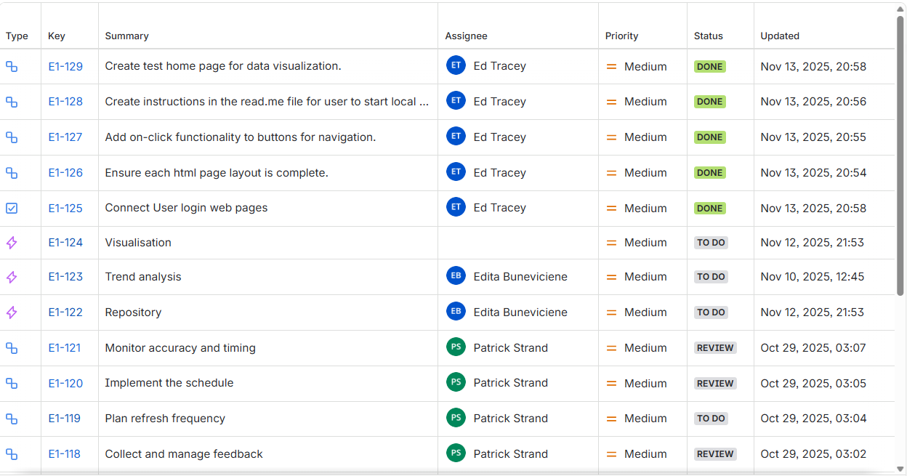

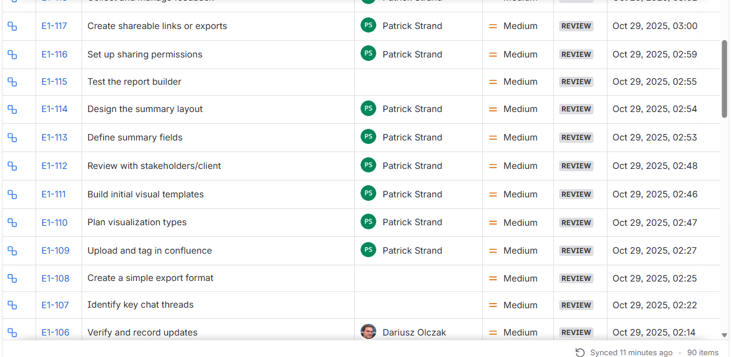

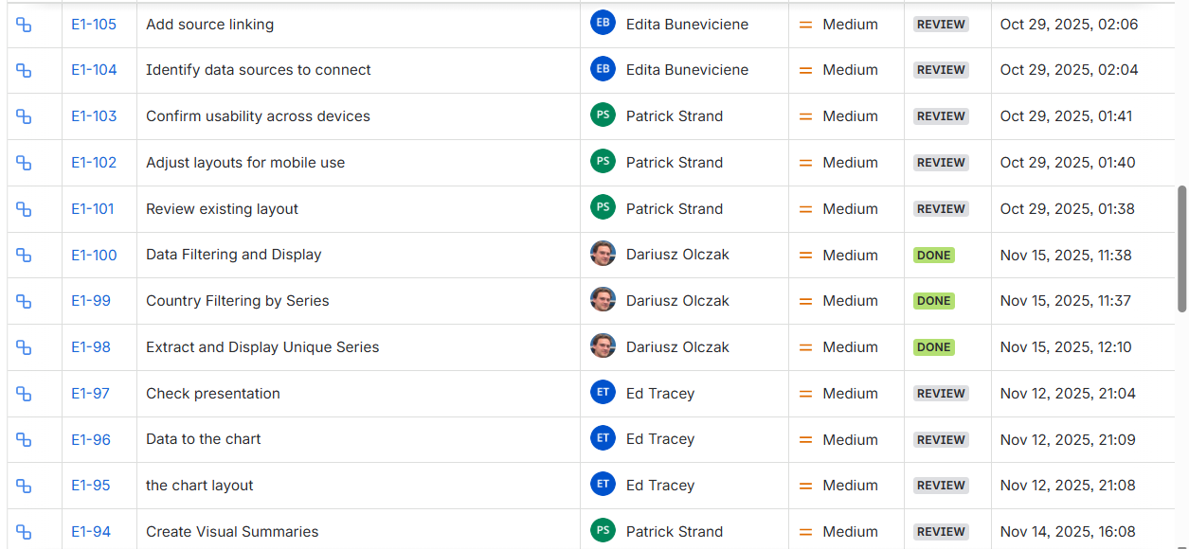

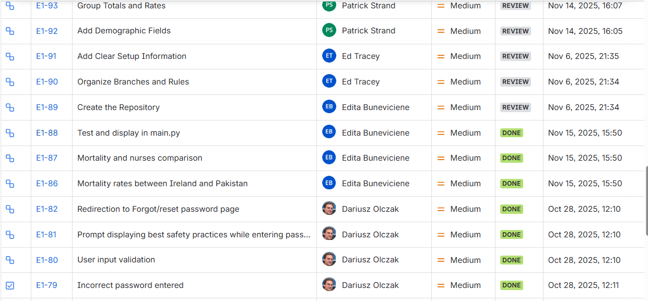

# User stories and subtask

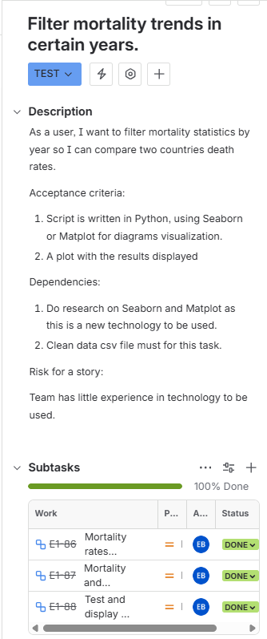 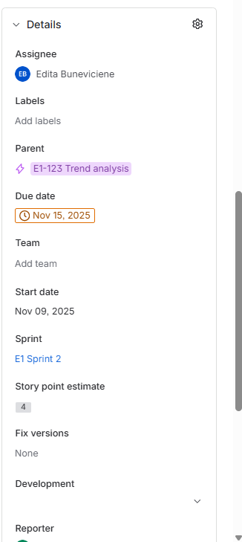

Subtask:

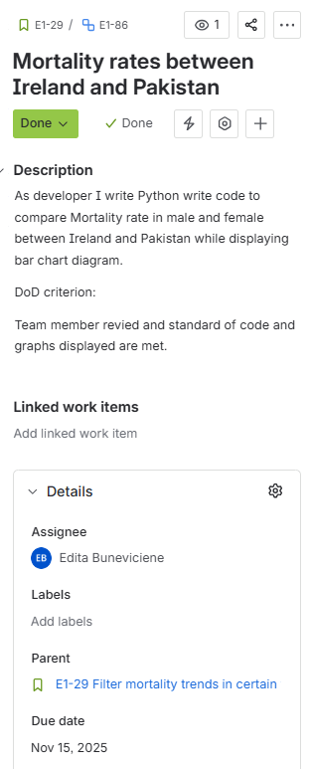 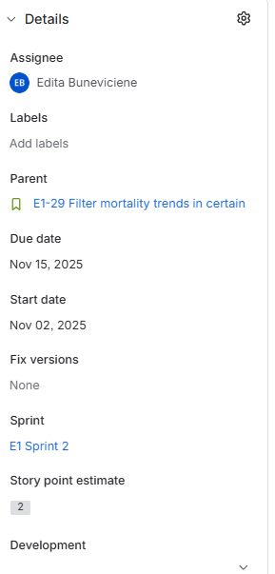

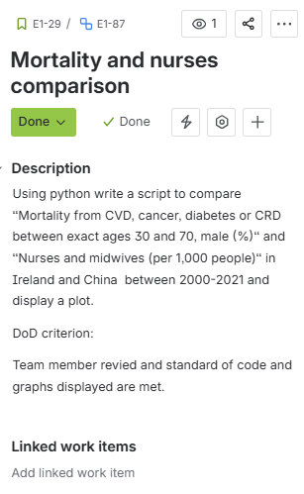 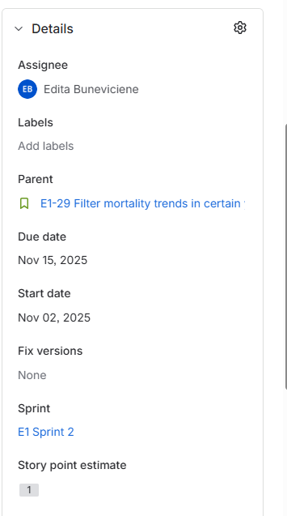

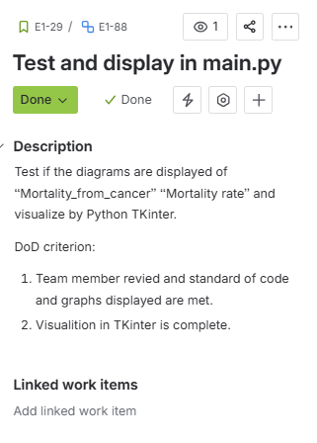 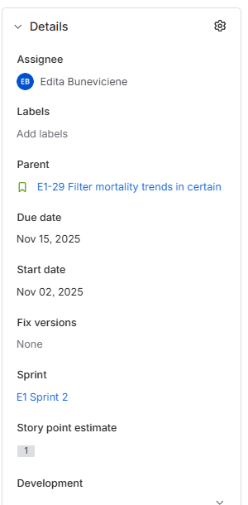

User story:

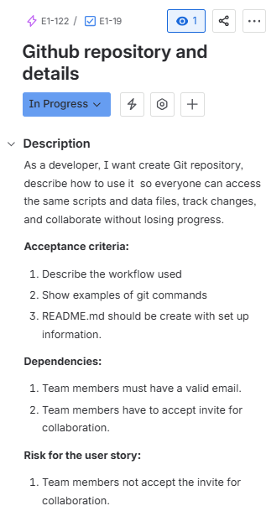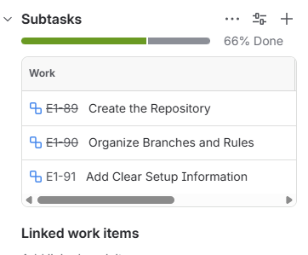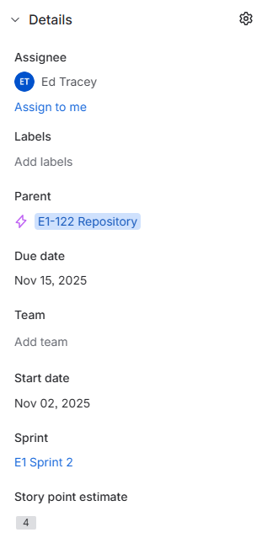

Subtasks:

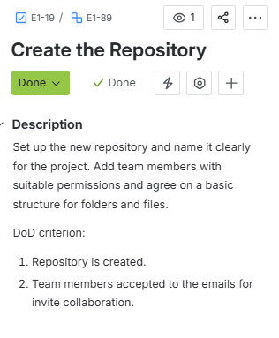 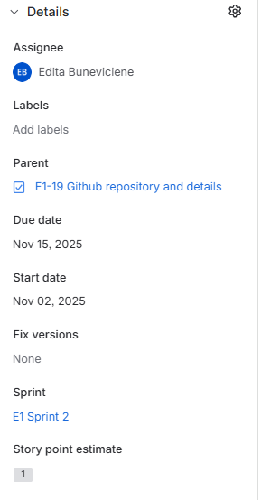

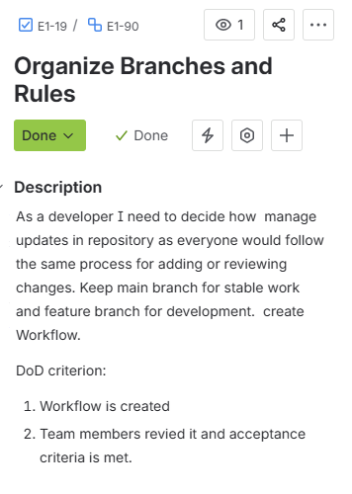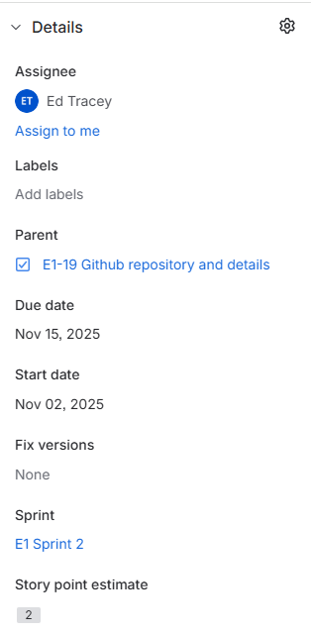

Confirmation of pull request from team member.

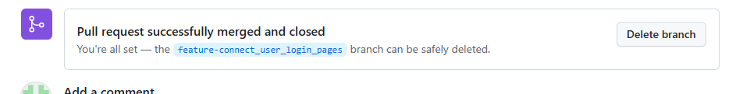

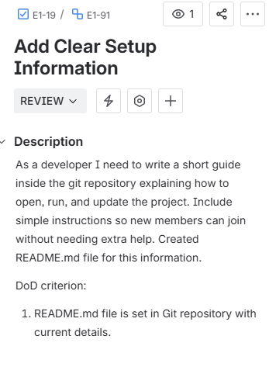 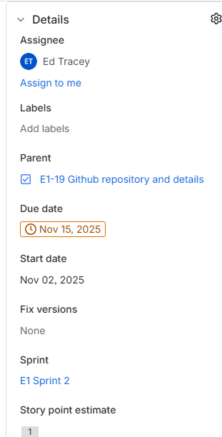

User story:

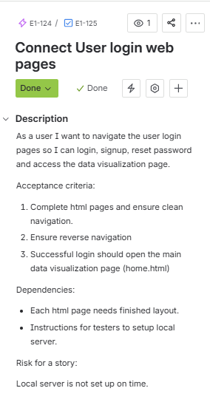 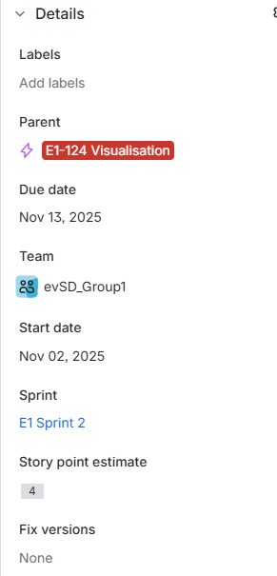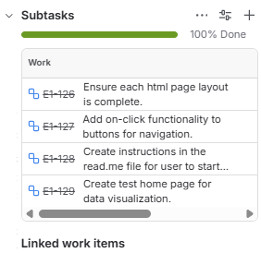

Subtasks:

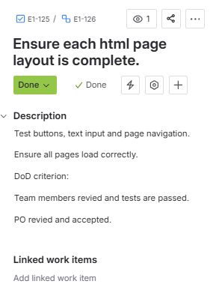 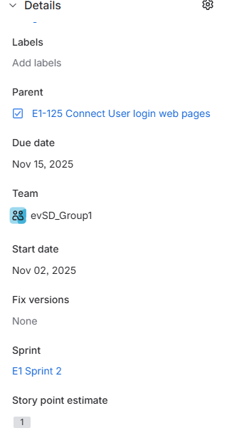

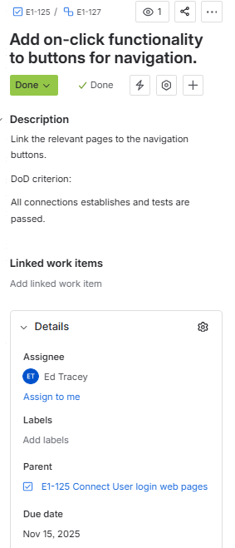 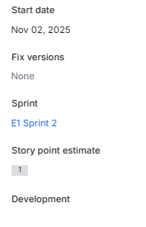

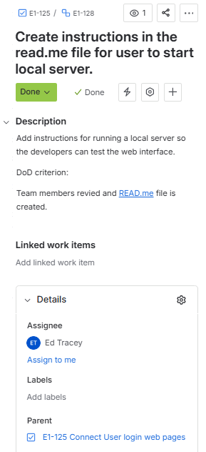 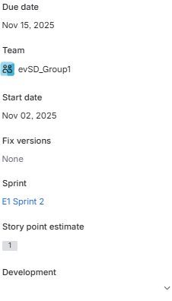

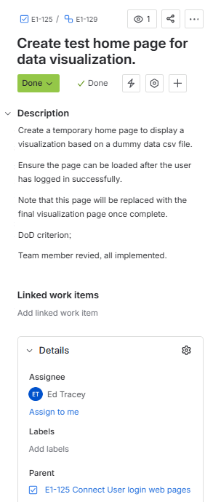 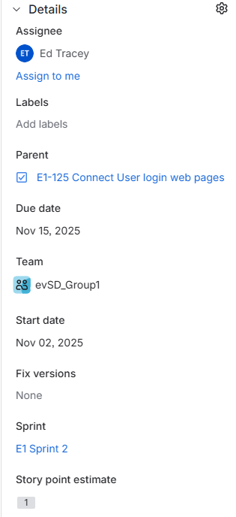

User story:

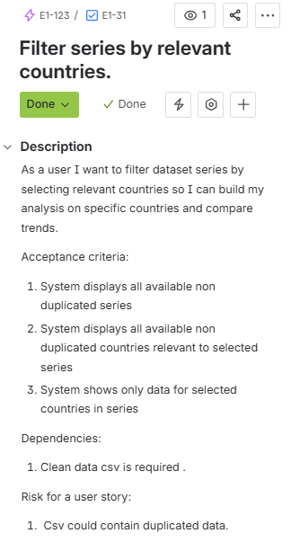 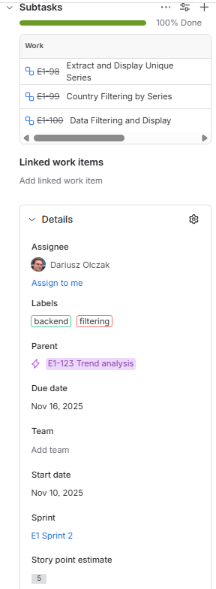

Subtasks:

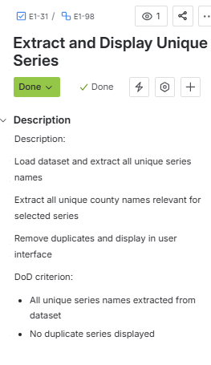 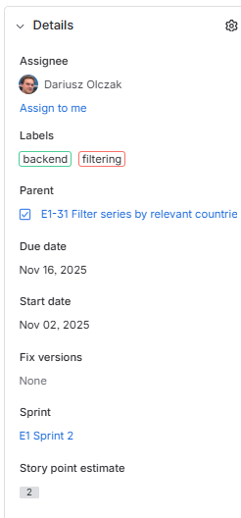

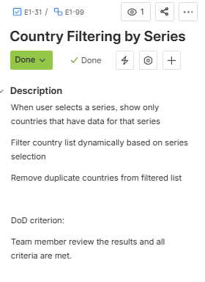 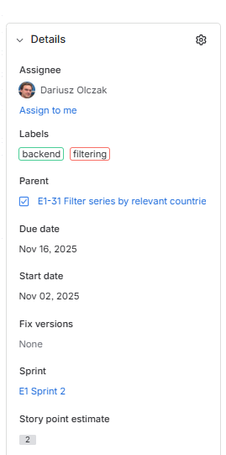

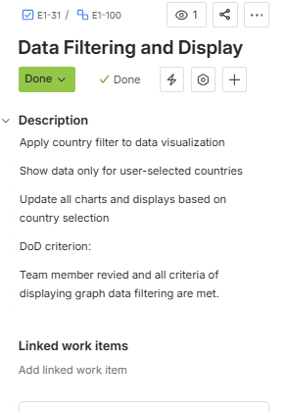 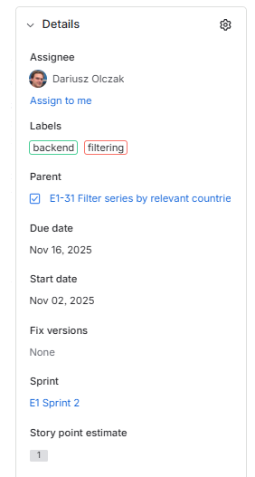

User story:

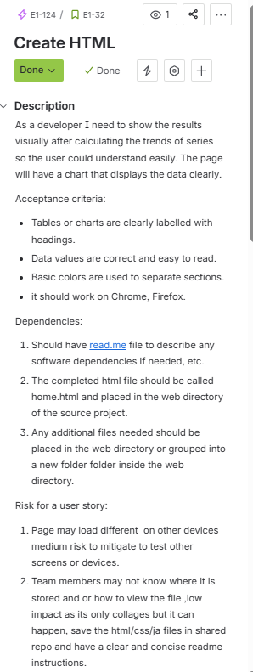 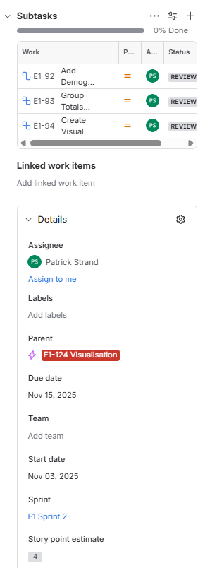

Subtasks:

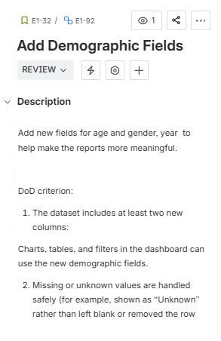 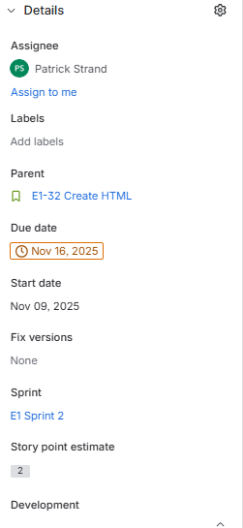

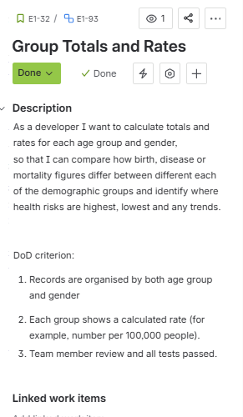 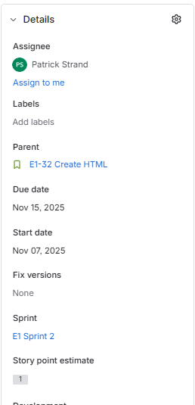

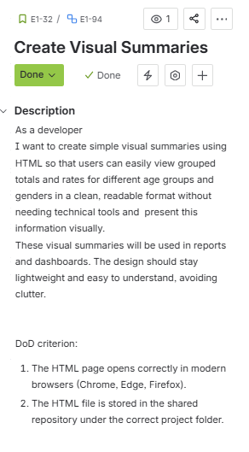 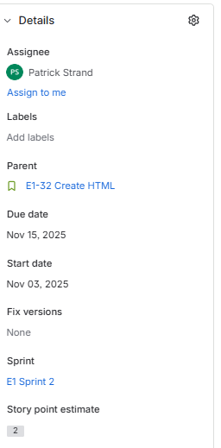

User story:

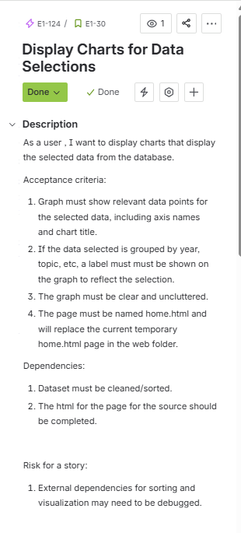 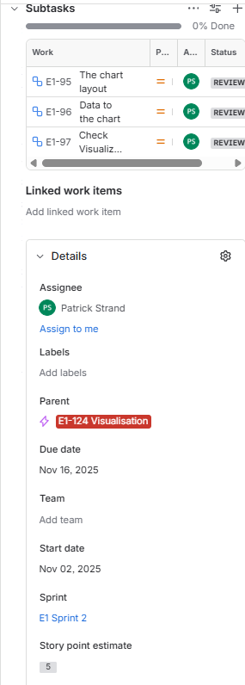

Subtasks:

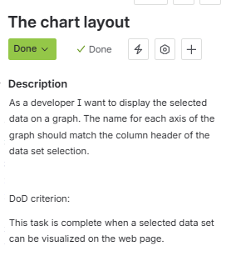 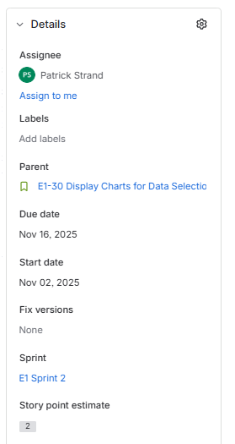

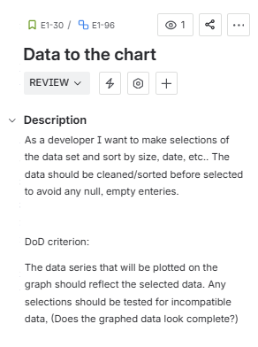 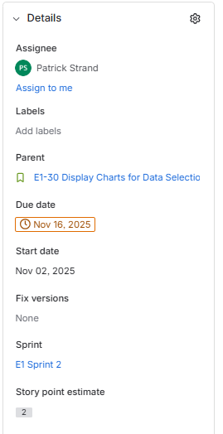

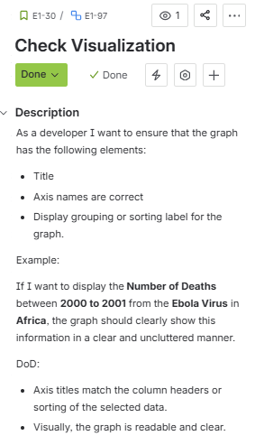 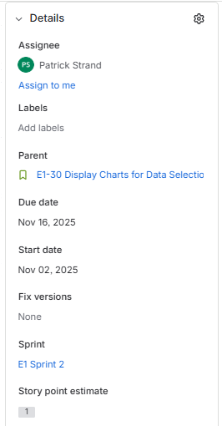

Planning Poker Process:

For the Poker process we had a zoom call. PO was Edita, scrum master was Dariusz. So we played a game and voted anonymously,giving a chance for everyone to experience how to conduct the game. We did the game for few tasks but is quite time consuming. So lastly loudly assigned the story points to the remaining tasks by average of the points of all members.

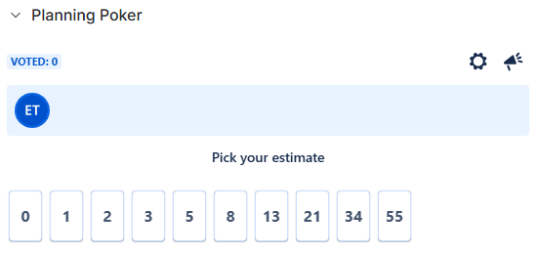

When scores were tied, the scrum master had the final decision.

# **Sprint planning /Backlog**

Backlog:

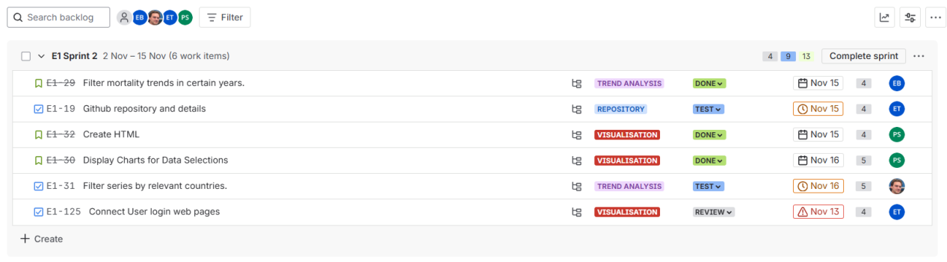

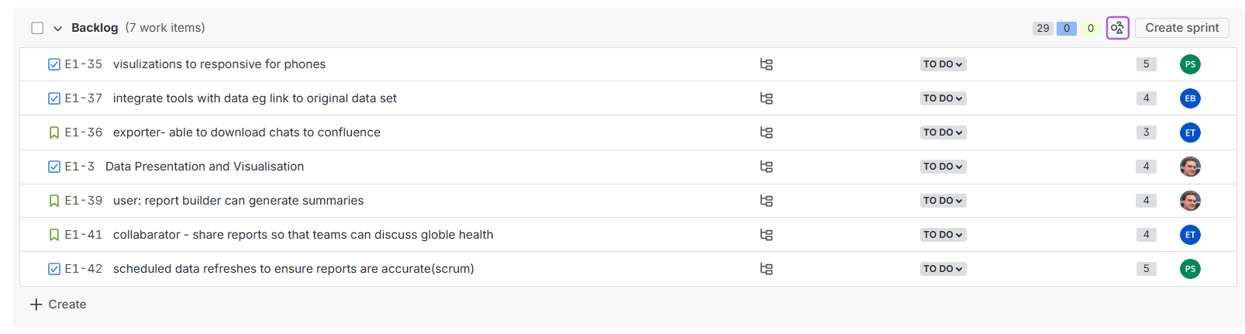

User story “Filter mortality trends in certain years” assigned to Edita Buneviciene.

Subtasks of “Filter mortality trends in certain years” are assigned to Edita Buneviciene too.

User story “Github repository and details” assigned to Ed Tracey.

Subtask “Create the Repository” is assigned to Edita Buneviciene.

Subtasks “Organize Branches and Rules” and “Add clear Setup Information” are assigned to Ed Tracey.

User story “Create HTML” is assigned to Patrick Strand. All subtasks belonging to this tasks are assigned to Patrick too.

User story “Display Charts for data Selections” is assigned to Patrick Strand. All belonging subtasks of the story are assigned to Patrick as well.

User story “Filter series by relevant countries” is assigned to Dariusz Olczak. All belonging subtasks are assigned to Dariusz Olczak.

User story “Connect User login web pages” is assigned to Ed Tracey. All belonging subtasks are assigned to Ed Tracey.

In this sprint we choose velocity and story point approach. Total 26 story points per sprint 2. In total 55 story points in backlog before completing sprint2.

Our 1 story points is equal 1.5 hour. So if a sub-task contains 2 estimated story point, it is equal 3 hours of work.

Timeline:

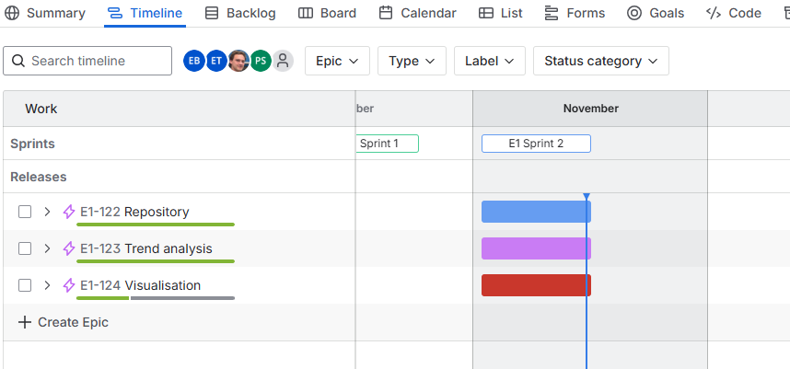

Scrum board screenshot:

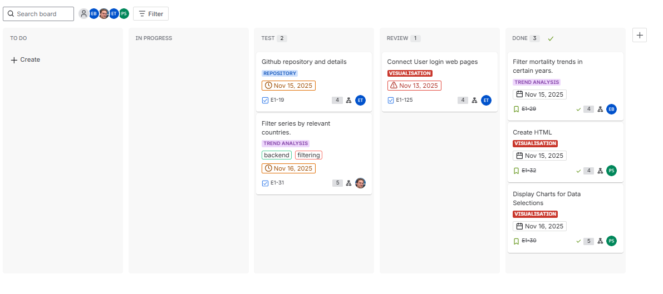

# Sprint 2 planning report

* [✅ Sprint planning checklist](" \l "Sprint2planningreport-Sprintplanningchecklist)
* [👥 Sprint team members](" \l "Sprint2planningreport-Sprintteammembers)
* [✏ Sprint planning meeting items](" \l "Sprint2planningreport-Sprintplanningmeetingitems)
  + [Agenda](" \l "Sprint2planningreport-Agenda)
  + [Previous sprint summary](" \l "Sprint2planningreport-Previoussprintsummary)
  + [Details](" \l "Sprint2planningreport-Details)
  + [Velocity tracking](" \l "Sprint2planningreport-Velocitytracking)
  + [Adjusted velocity tracking](" \l "Sprint2planningreport-Adjustedvelocitytracking)
  + [Capacity planning](" \l "Sprint2planningreport-Capacityplanning)
  + [Potential risks](" \l "Sprint2planningreport-Potentialrisks)
* [?? Sprint planning resources](" \l "Sprint2planningreport-Sprintplanningresources)
  + [Sprint boards and retrospectives](" \l "Sprint2planningreport-Sprintboardsandretrospectives)
  + [Team resources and definitions](" \l "Sprint2planningreport-Teamresourcesanddefinitions)

## IMG_256 Sprint planning checklist

|  |  |  |
| --- | --- | --- |
| **Preparation** | **Meeting** | **Follow up** |
| * Set up GitHub * Add Members * review backlog and make sure it reflect the project * Write script to do some comparisons * Git commands * Start working on HTML | * Communication via WhatsApp * Zoom call | * Git is set * Code is working * weekly updates on Jira * Mockup of HTML |

## IMG_257 Sprint team members

|  |  |
| --- | --- |
| **Name** | **Role** |
| [Dariusz Olczak](https://evsd1.atlassian.net/wiki/people/70121:36abc9b4-dd97-4b78-a15c-ba8450bb8d25?ref=confluence" \t "_blank) | Scrum master |
| [Edita Buneviciene](https://evsd1.atlassian.net/wiki/people/712020:d55b7260-2e5b-49d6-87e6-228b14f15d65?ref=confluence" \t "_blank) | PO |
| [Ed Tracey](https://evsd1.atlassian.net/wiki/people/712020:22df8da7-d258-4e96-a565-5d1f5c417764?ref=confluence" \t "_blank) | Developer |
| [Patrick Strand](https://evsd1.atlassian.net/wiki/people/712020:06192cf4-96c0-4b29-a4dc-6553536b0765?ref=confluence" \t "_blank) | Developer |

## IMG_258 Sprint planning meeting items

Use this template to structure your meeting, set expectations and goals, and define the backlog for the upcoming sprint. For detailed instructions and best practices, see our [sprint planning guide](https://www.atlassian.com/agile/scrum/sprint-planning) and review how to [estimate story points](https://www.atlassian.com/agile/project-management/estimation).

### Agenda

1. Sprint 1 closed
2. User stories in Sprint 1 completed
3. User stories in Sprint 1 completed
4. Dataset is cleaned.
5. Mockups of user stories are created

### Previous sprint summary

|  |  |
| --- | --- |
| **Sprint theme** | **Dataset download, clean, create mockups.** |
| **Story points** | in Sprint 1 story points for user stories was 35. it was no user stories left for next sprint. |
| **Summary** | Dataset was picked for a project, Jira and Confluence set up, connected to each other. the code to clean dataset was created. Mockups to implement user stories were created. |

### Details

|  |  |
| --- | --- |
| **Start date** | **01 Oct 2025** |
| **End date** | 02 Nov 2025 |
| **Sprint theme** | Dataset download, clean, create mockups. |

### Capacity planning

You can customize this template to change or add capacity measurements. You can also review older sprints by adding columns.

|  |  |  |
| --- | --- | --- |
|  | **Current sprint** | **Previous sprint** |
| **Total days** | 14 | 28 |
| **Team capacity** | 100% | 100% |
| **Projected capacity** | 26 | 35 |
| **Individual capacity** | [Edita Buneviciene](https://evsd1.atlassian.net/wiki/people/712020:d55b7260-2e5b-49d6-87e6-228b14f15d65?ref=confluence" \t "_blank) 5  [Dariusz Olczak](https://evsd1.atlassian.net/wiki/people/70121:36abc9b4-dd97-4b78-a15c-ba8450bb8d25?ref=confluence" \t "_blank) 5  [Ed Tracey](https://evsd1.atlassian.net/wiki/people/712020:22df8da7-d258-4e96-a565-5d1f5c417764?ref=confluence" \t "_blank) 7  [Patrick Strand](https://evsd1.atlassian.net/wiki/people/712020:06192cf4-96c0-4b29-a4dc-6553536b0765?ref=confluence" \t "_blank) 9 | 8 points  9 points  10 points  8 points |

### Potential risks

|  |  |
| --- | --- |
| **Risk** | **Mitigation** |
| The team has a smaller buffer than they expected. | The team may need to reduce backlog for next sprint. |
|  |  |

# Git worklow

This project uses the **GIT Feature Branch** workflow as shown below.

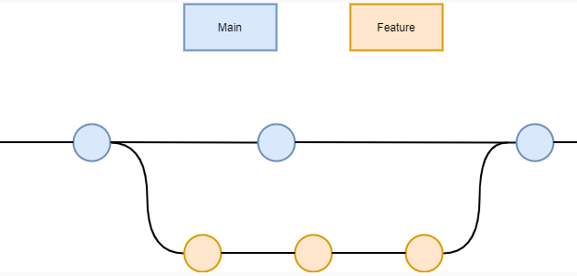

When a new feature is to be added, the developer first creates a new branch from the main branch.

When the feature branch has been tested, a pull request is made to merge the feature into the main branch. The pull request is reviewed by the development team, and any requested changes or questions are addressed before merging into the main branch.

**Git commands**

**What are the differences between git blame, git log and git status?**

Status - checks the current status of the branch you are currently on, the *git status* command is used. It will show files that have been modified and files that are not yet tracked. Below shows an untracked file that was added to the source code.

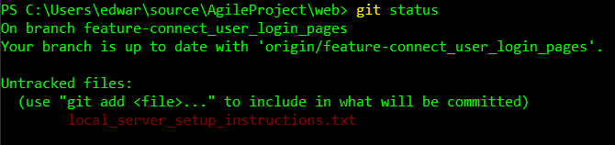

Git log- allows developers to view the entire commit history of a repository - helping them track changes, review project progress, and identify when and by whom changes were made.

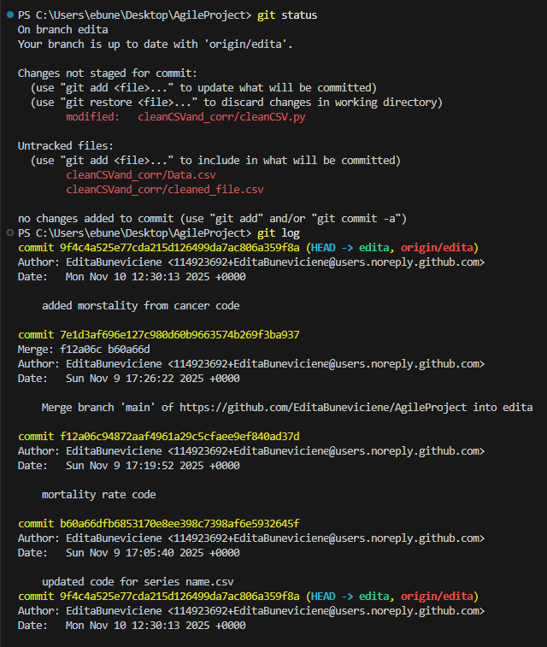

Git blame, it gives the information of each line about who edited it, giving the last commit that modified the line, the author, the timestamp of the change, the line number and code content (optionally).

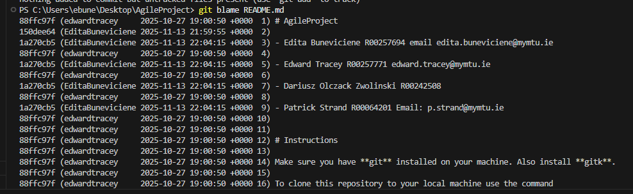

Clone

To clone a remote repository, use the *git clone <url>* command.

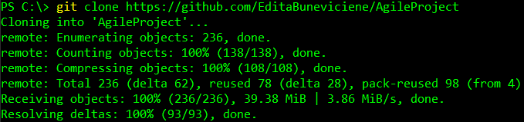

Branch

To create a branch, use the following command, with the name of the new branch

**git branch <name of new branch>**

Checkout

To jump onto the new branch, use the *checkout* command.

**git checkout <name of branch to switch to>**

Adding Files

To add the untracked files, the command ***git add \****can be used to add all untracked files or the command ***git add <filename>***can be used to add a specific file.



Committing Changes

To commit the newly added files we can use the *commit* command.

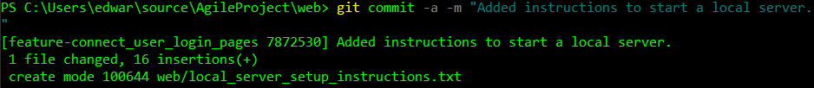

Push

Because the newly added files and changes only exist locally, we need to push the changes to the remote repository using the *git push* command.

If the branch was created locally and does not yet exist on the remote repository, we can use the following command.

***Git push -u origin <branch\_name>***

***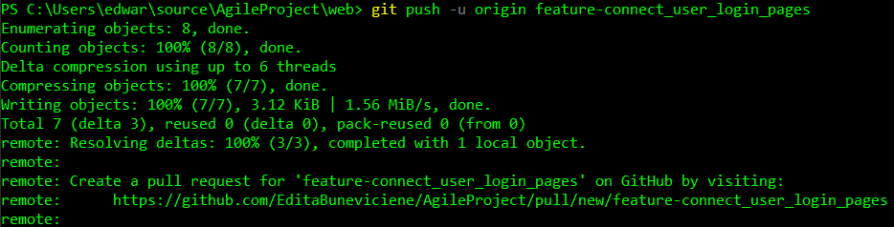***

When further changes are made to the source code, they are committed and then pushed to the remote repository.

Diff

We can use *git diff* to view any changes that have been made to tracked files. We can then commit these changes and push to the remote.

Lines highlighted in red are the old text and lines highlighted in green are the new additions.

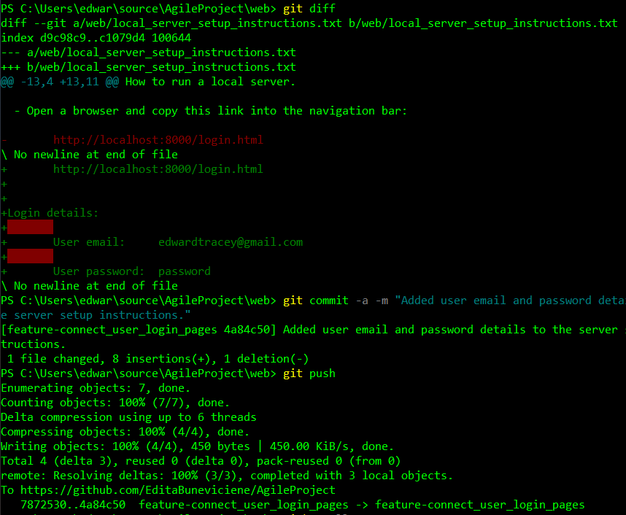

Git stashing

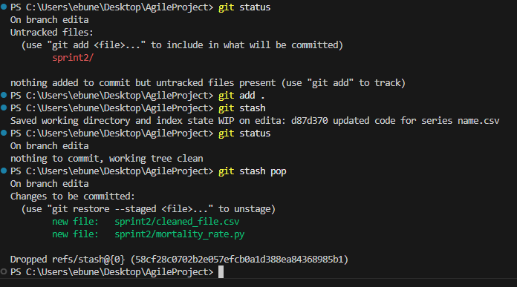

.gitignore used to ignore Data\_Cleaned.csv file because everytime main.py runs, it creates this file.

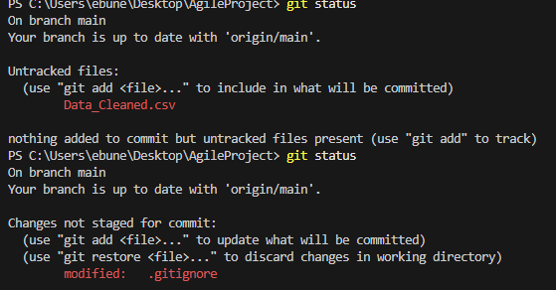

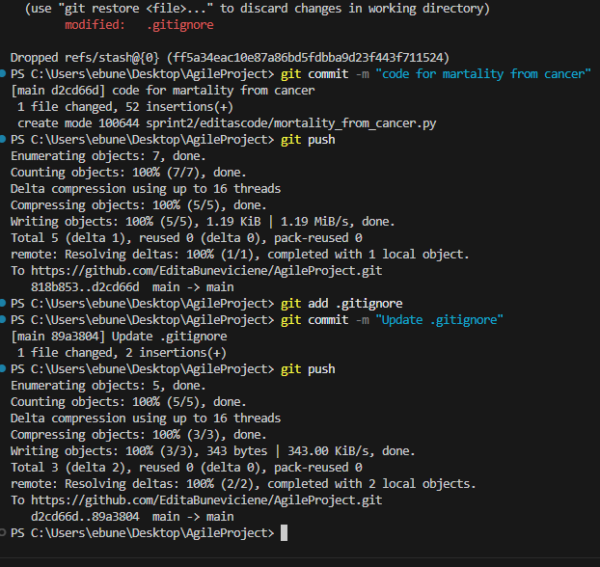

Git merge used to merge into main from edita branch.

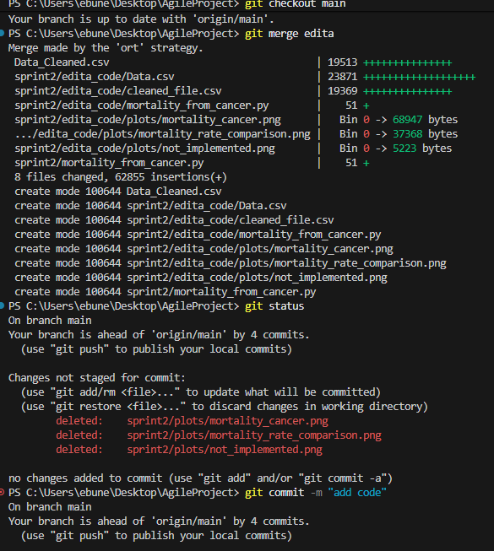

Checking for tags

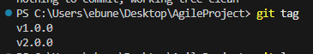

Untracked file on the branch. Newly created.

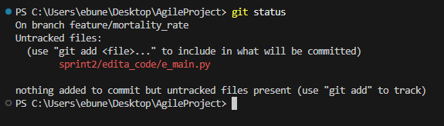

Git reflog to track orphaned files.

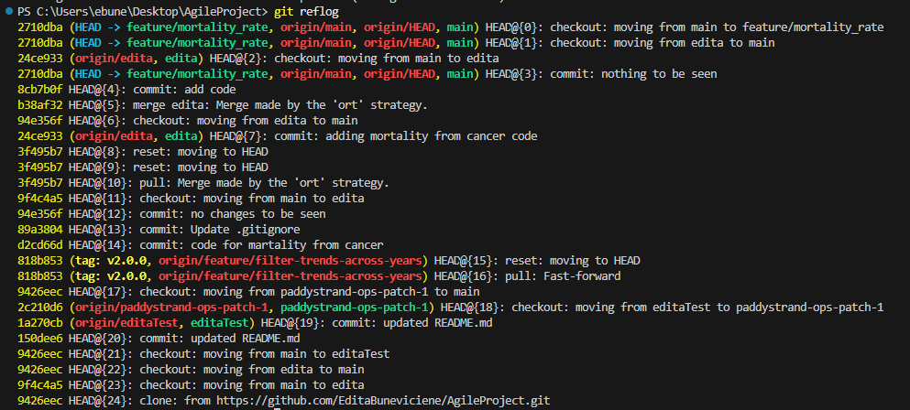

Git:

-feature branch

-stash

-conflict/conflict resolving

-merging

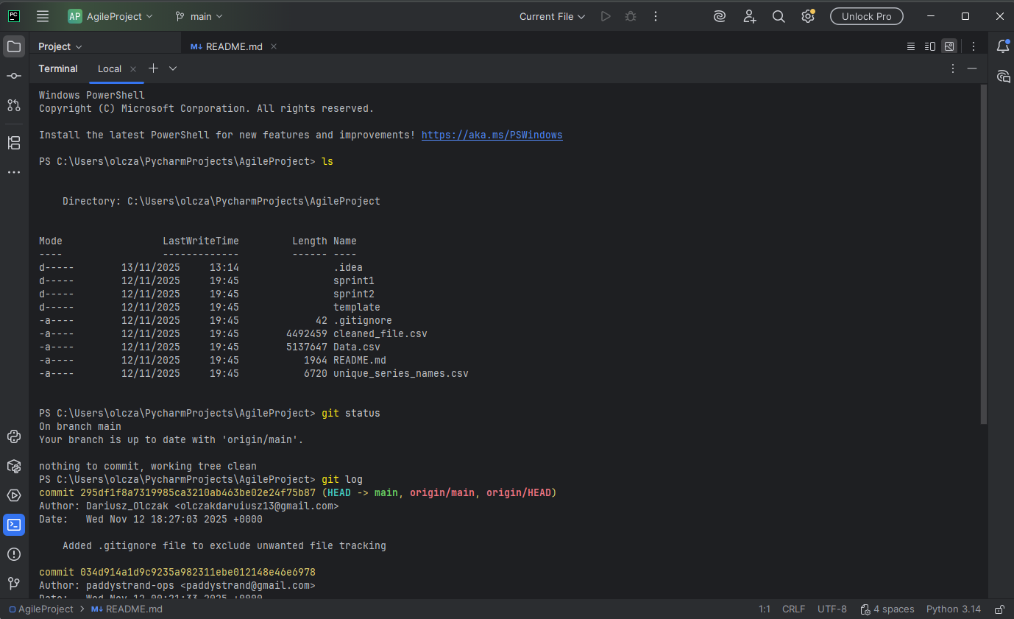

Creating branch feature/filter-columns

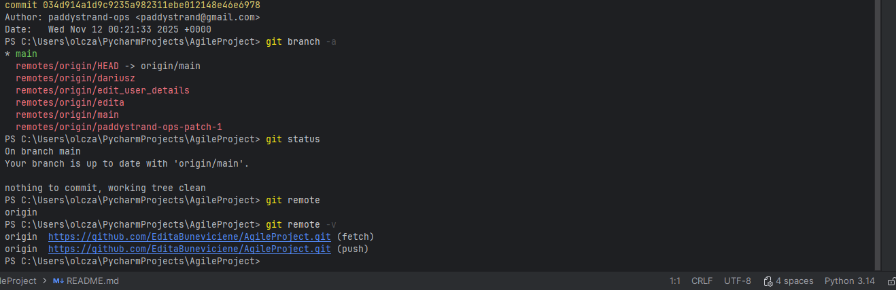

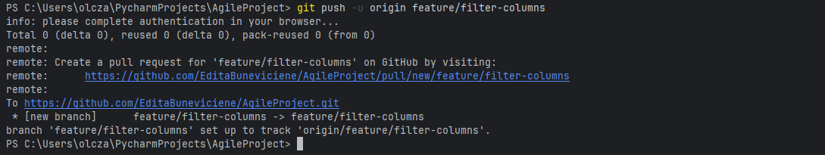

Creating branch dariusz off the branch feature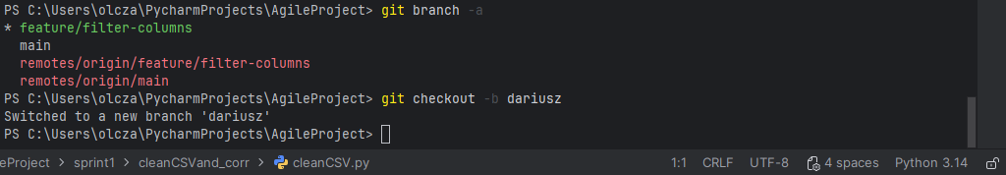

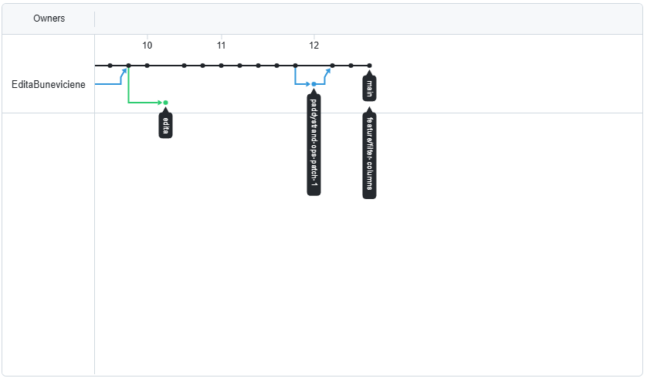

Stashing:

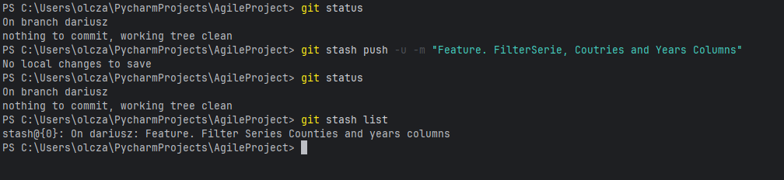

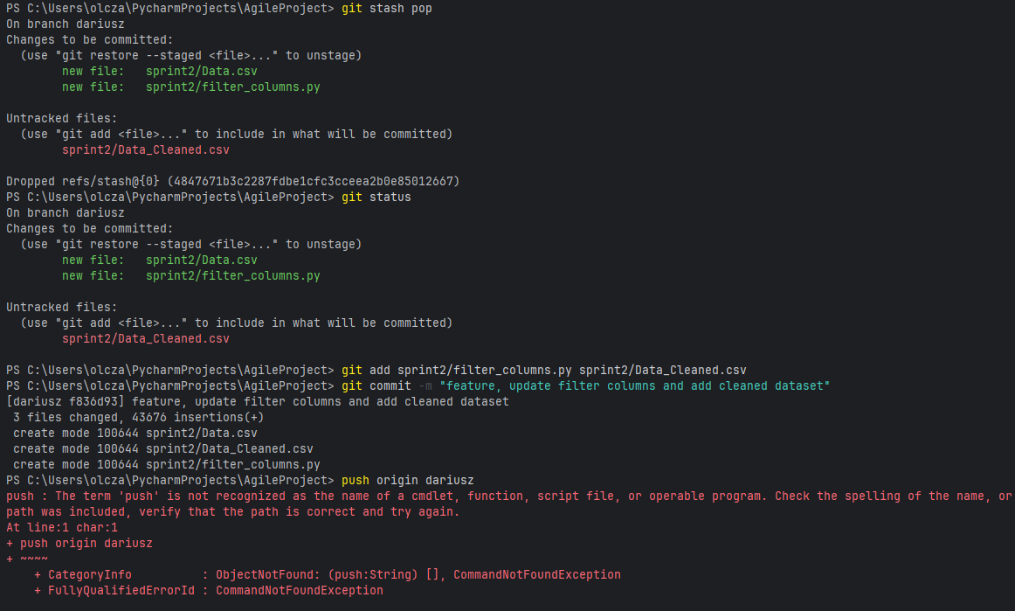

A conflict in .gitignore file on branch dariusz happened and had to be resolved by removing three lines to resolve conflict

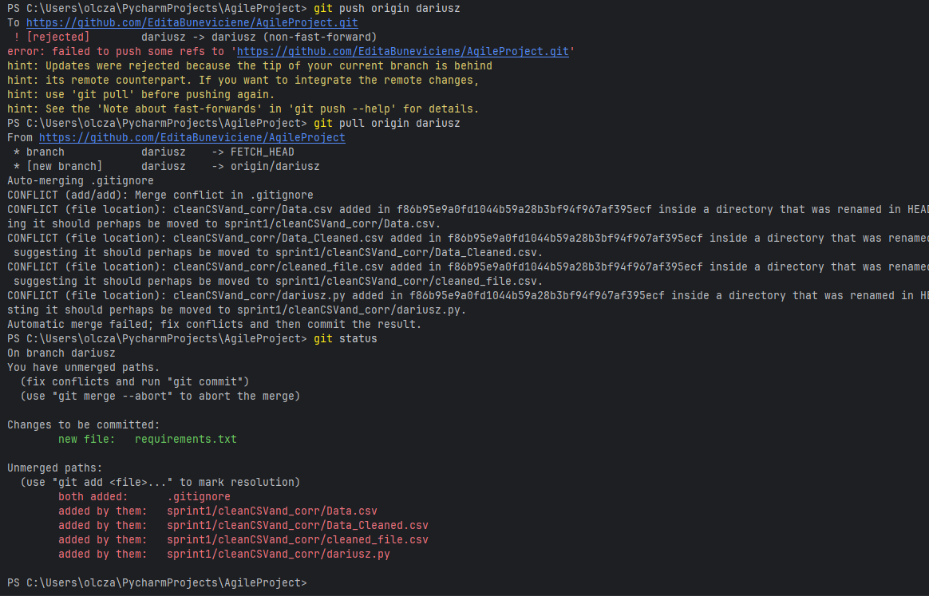

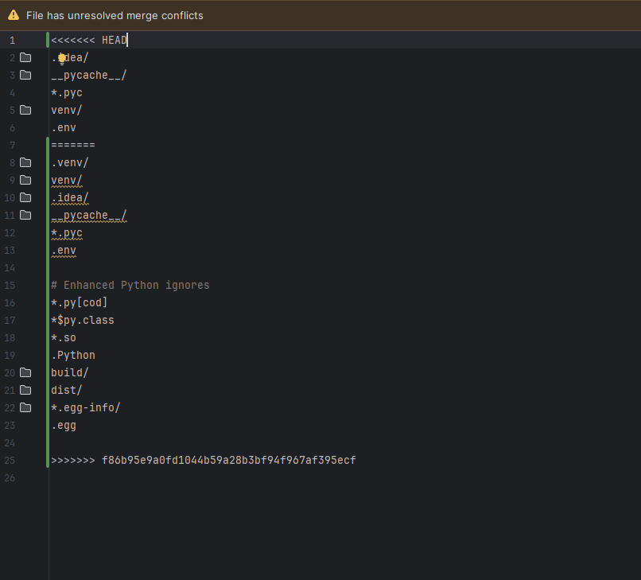 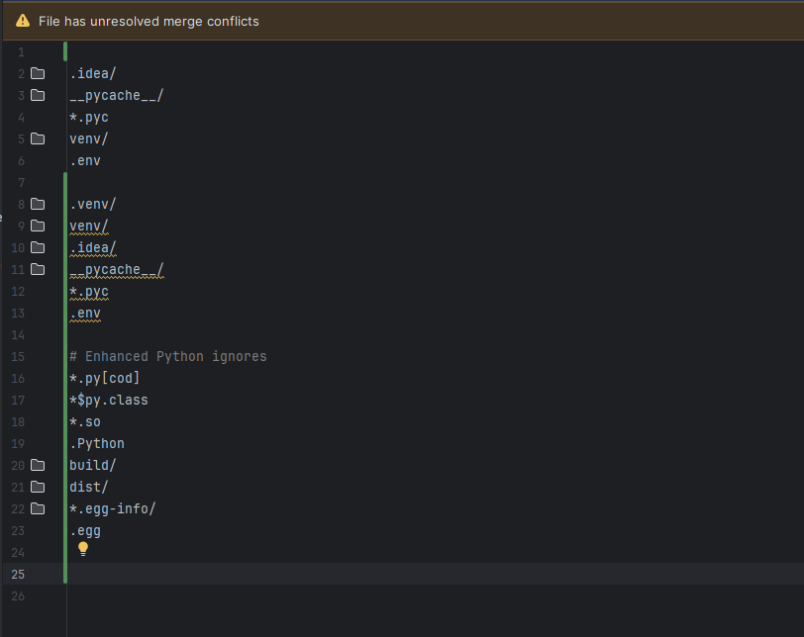

Pushing to changes to branch dariusz

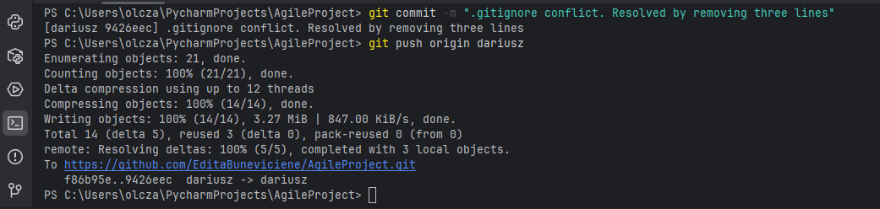

Pulling current version from branch feature/filter-columns

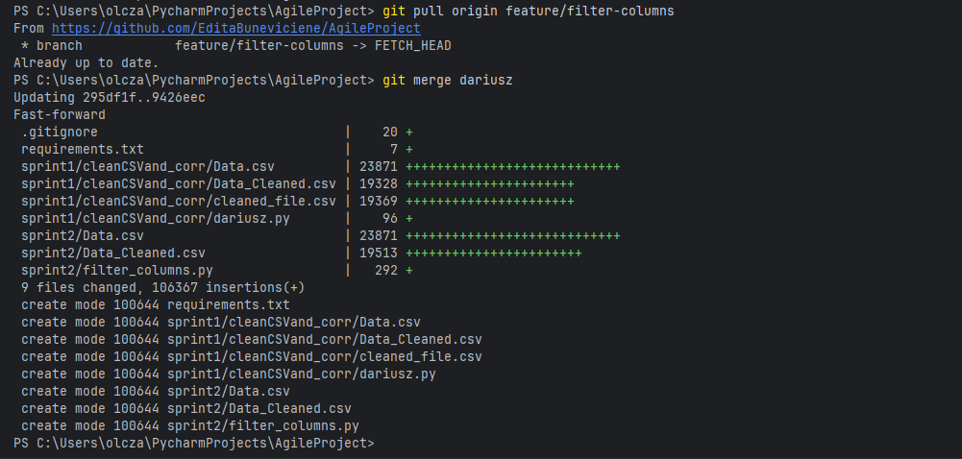

Merging feature branch with main branch

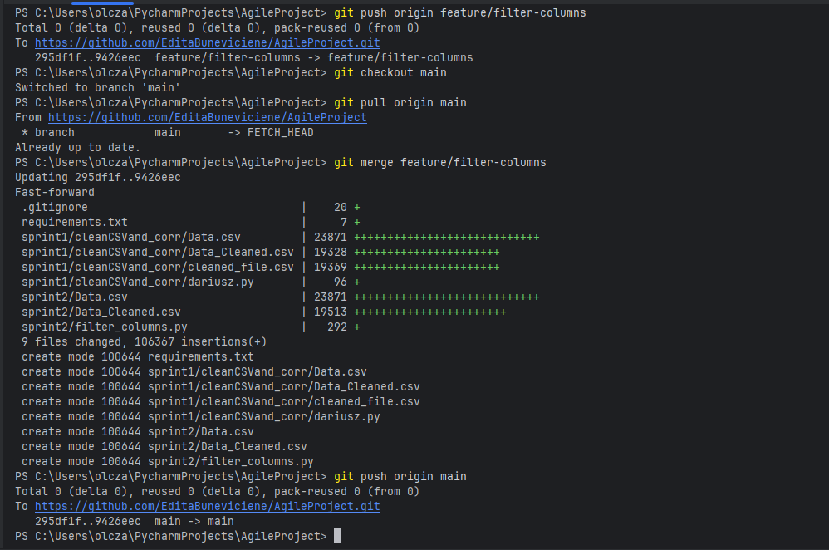

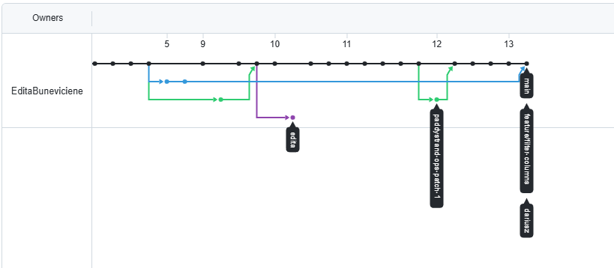

Removing dariusz branch and feature branch as no longer need:

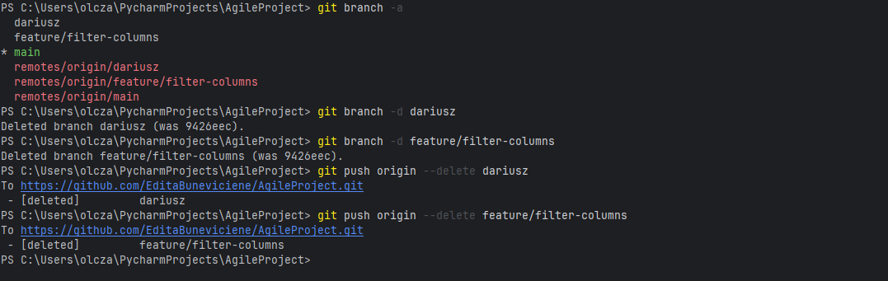

Git checking branch and log:

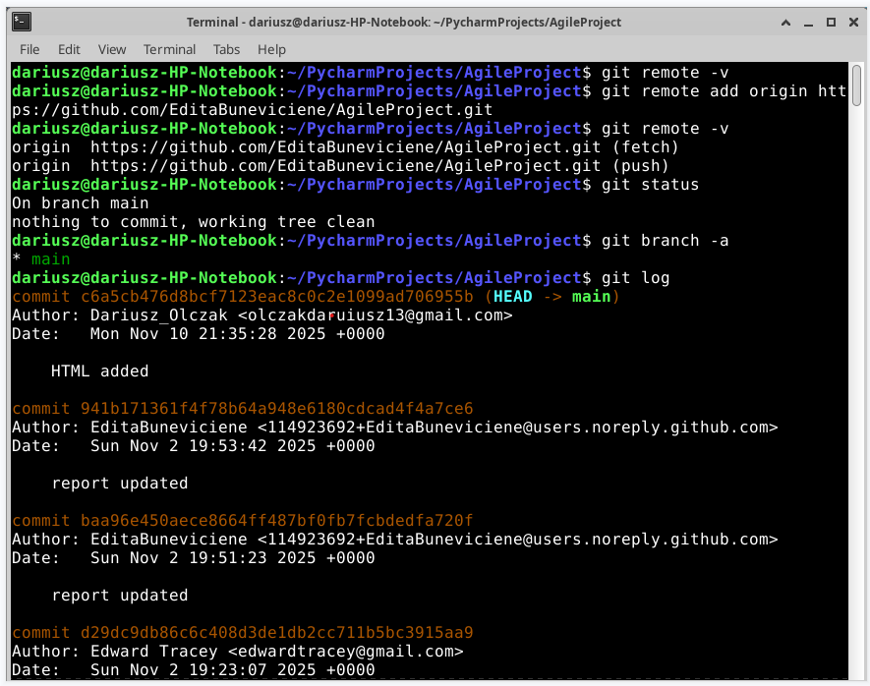

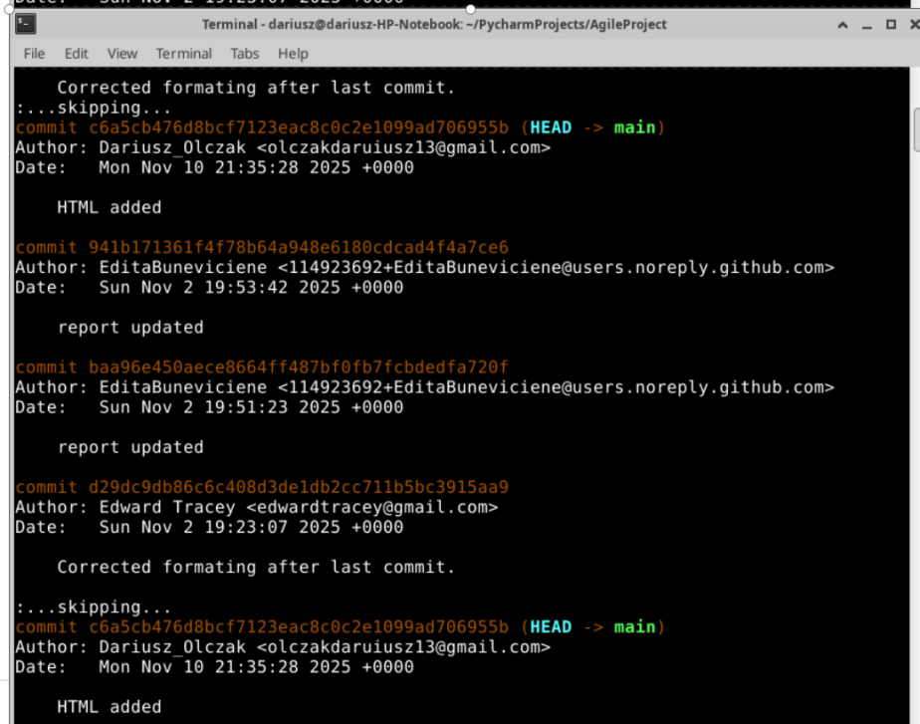

Merging:

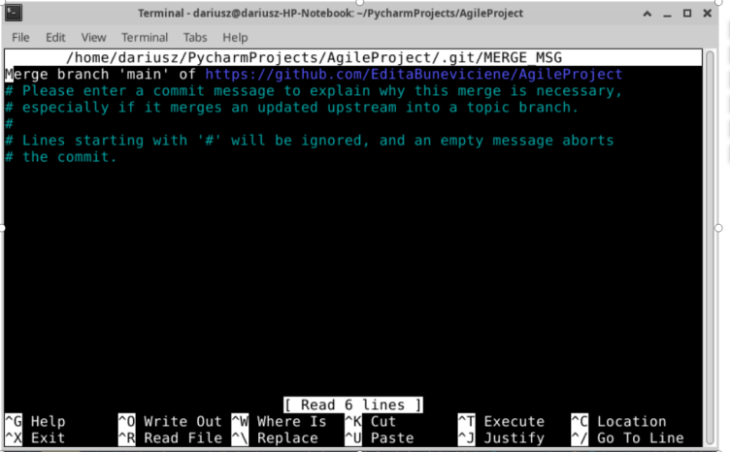

Pulling latest changes: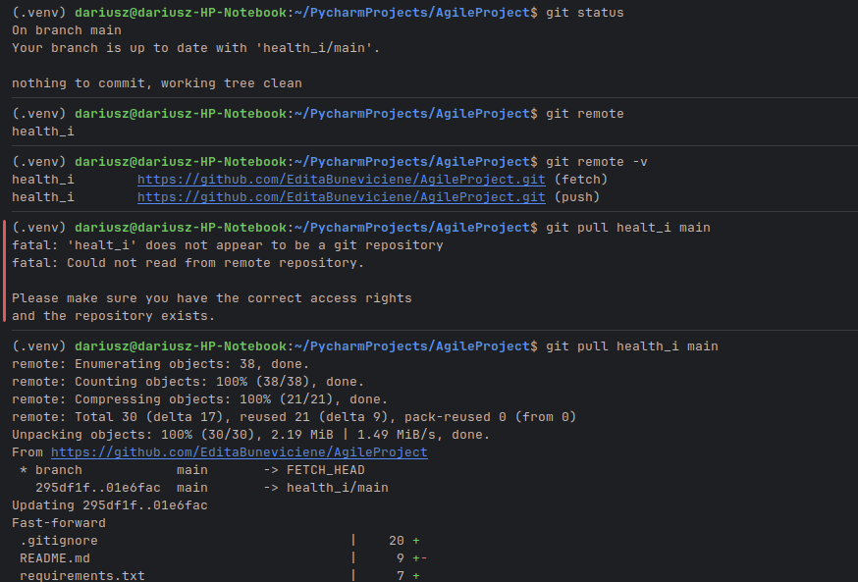

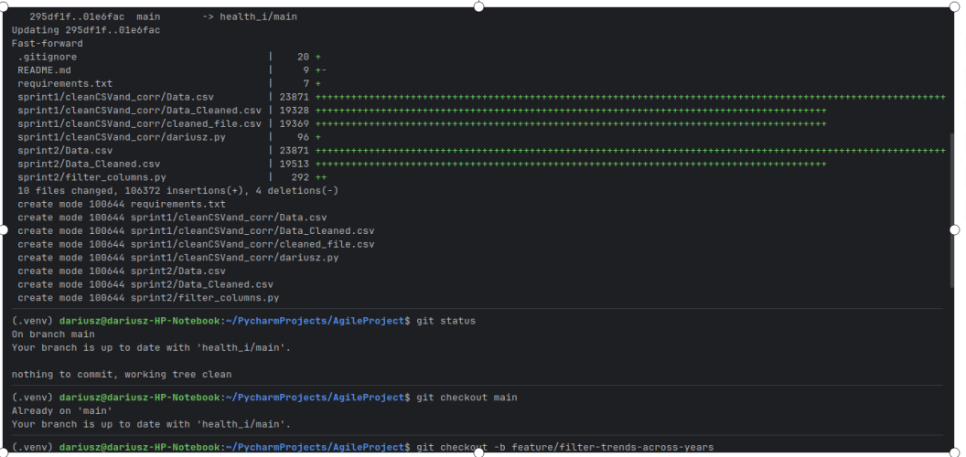

Creating feature branch and developer branch out of feature branch:

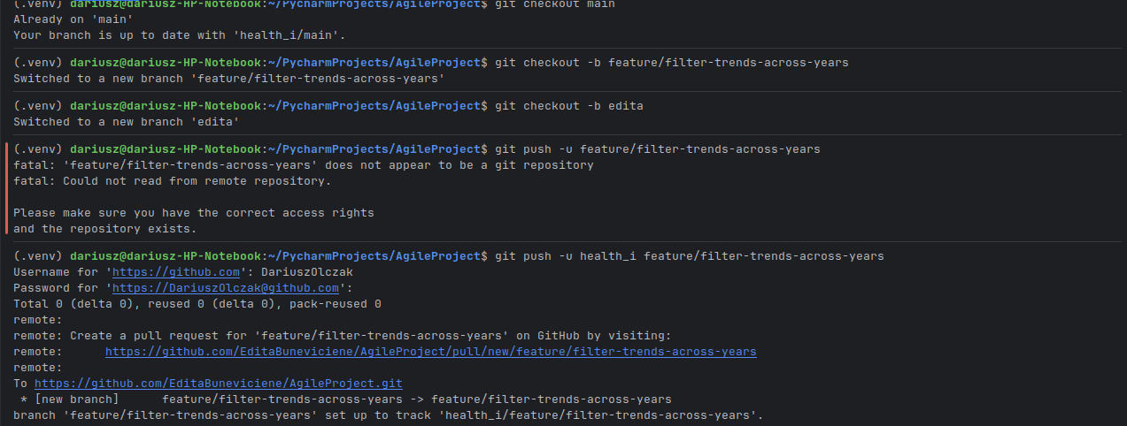

Pushing latest commit from main to feature branch:



Creating feature branch and developer branch out of feature branch:



Pushing latest commit from main to feature branch:



Switching to feature branch and developer branch to commit changes: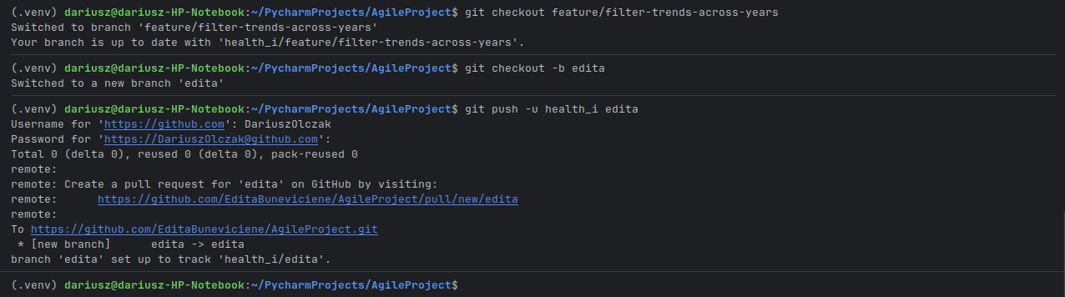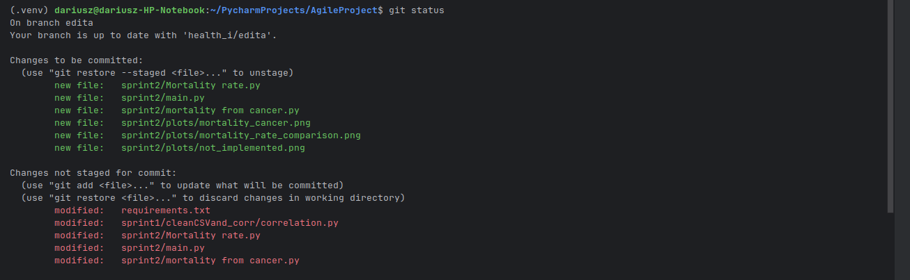

Commiting changes:

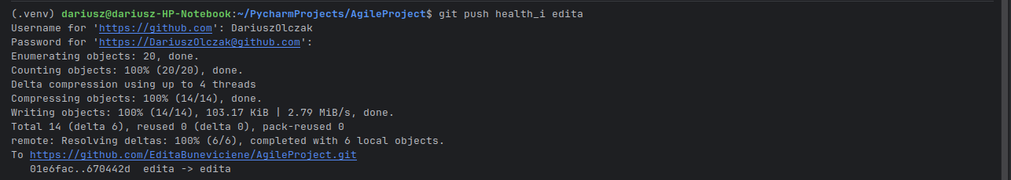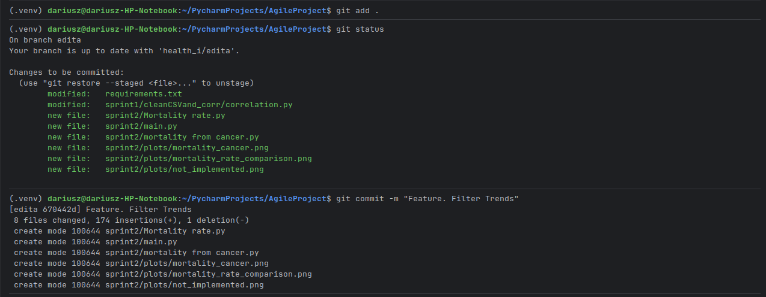

Merging Feature Branch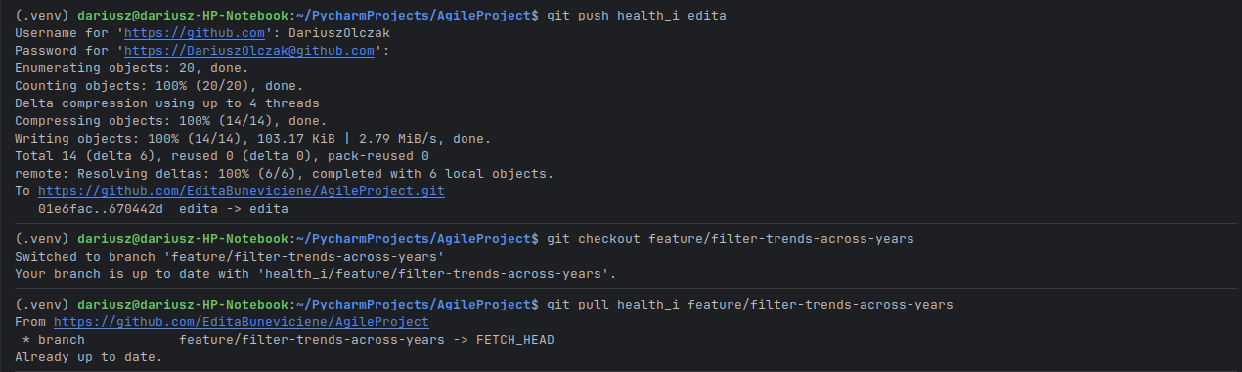

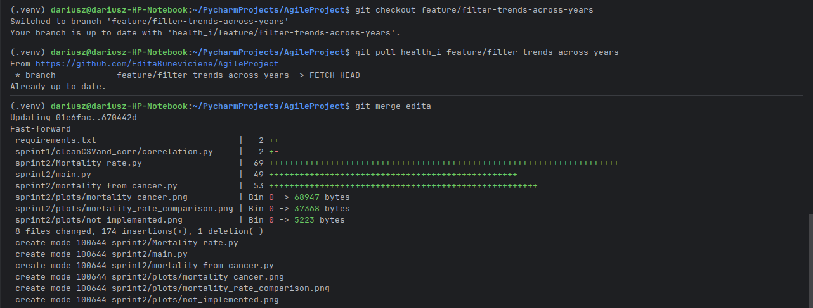

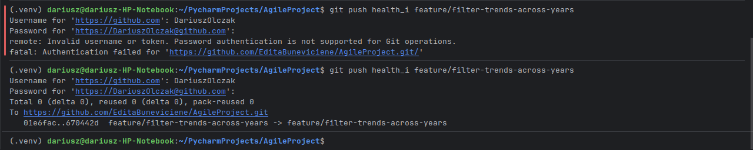

Pushing next improved changes

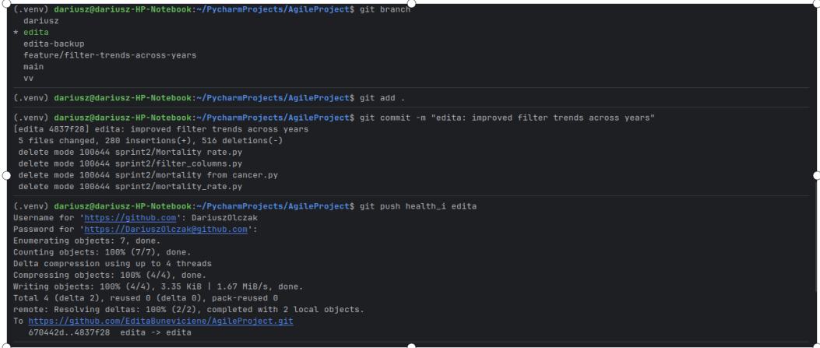

Creating second dev branch off feature branch

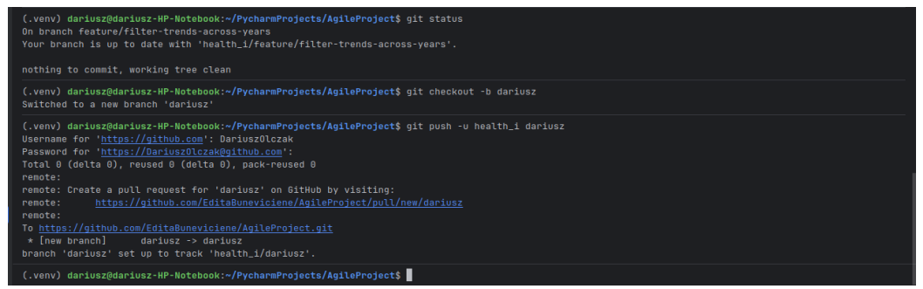

Merging changes with feature branch

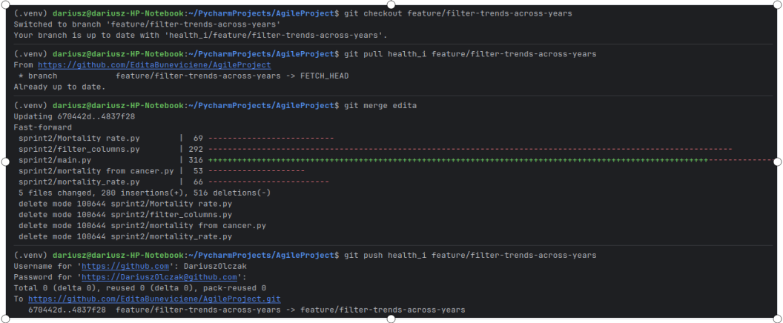

Making changes to wrong branch and stashing work to move to correct branch

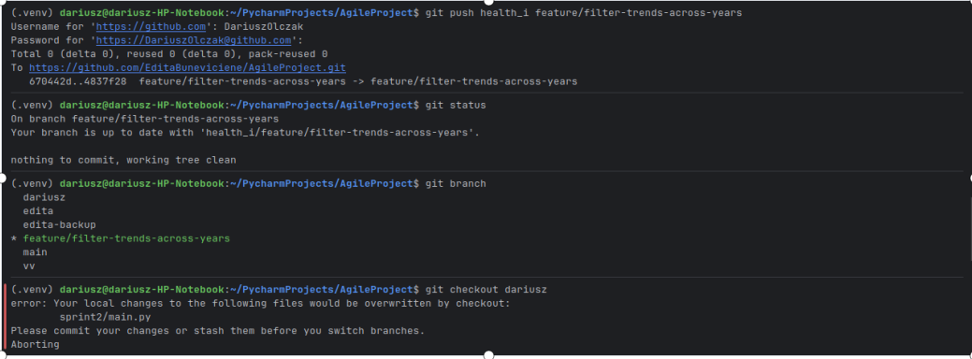

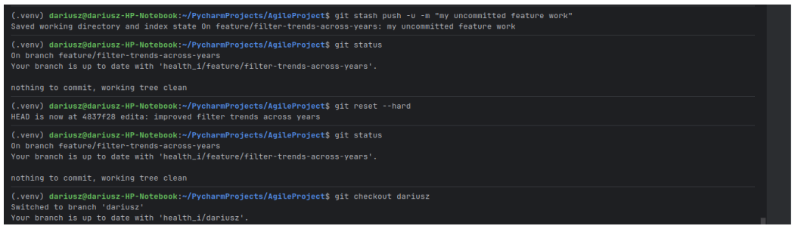

Retrieving stash

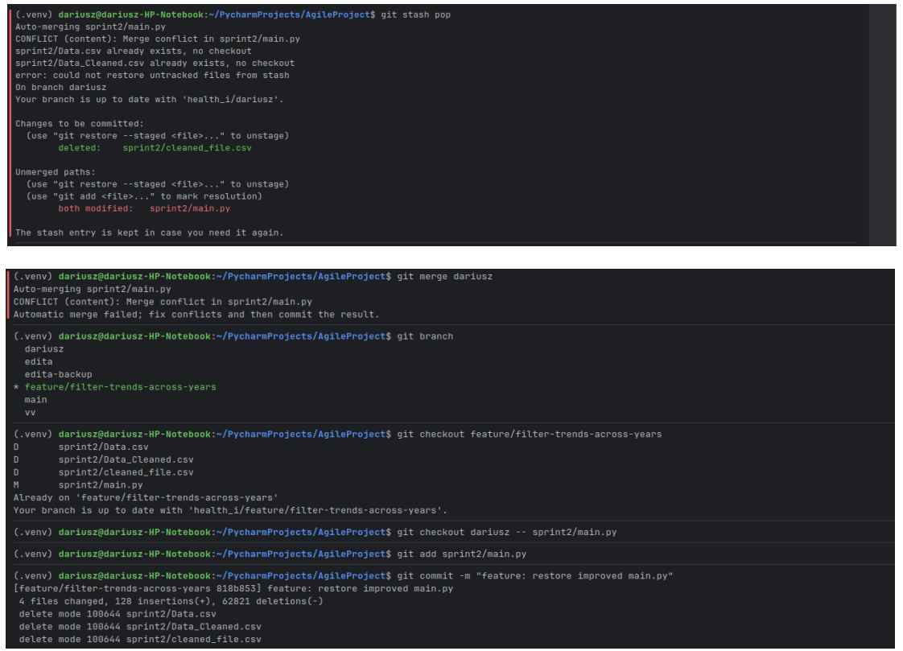

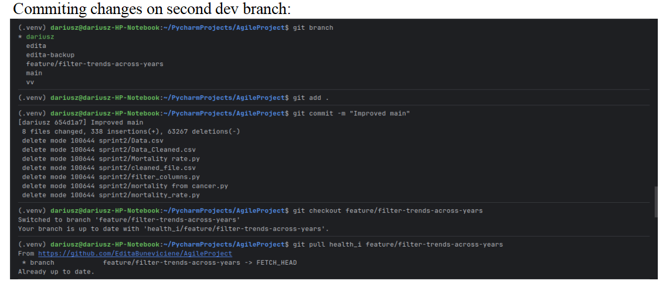

Conflicts occurred and had to be solved

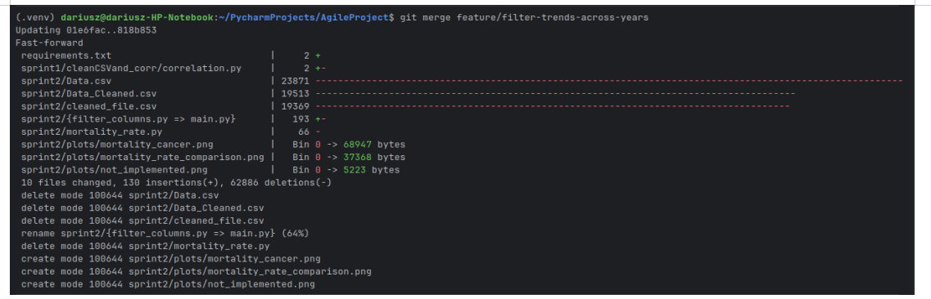

After solving conflicts

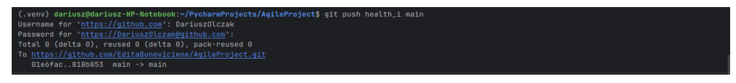

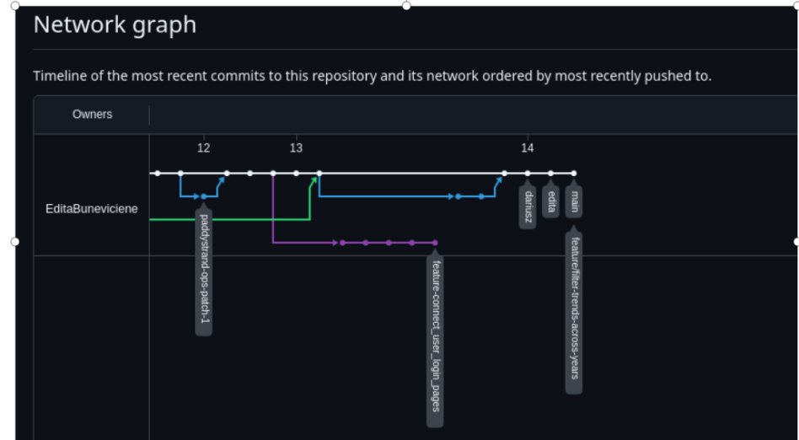

**Git Tagging**

**Tagging Sprint versions**

Checking for already existing tags and checking commit history:

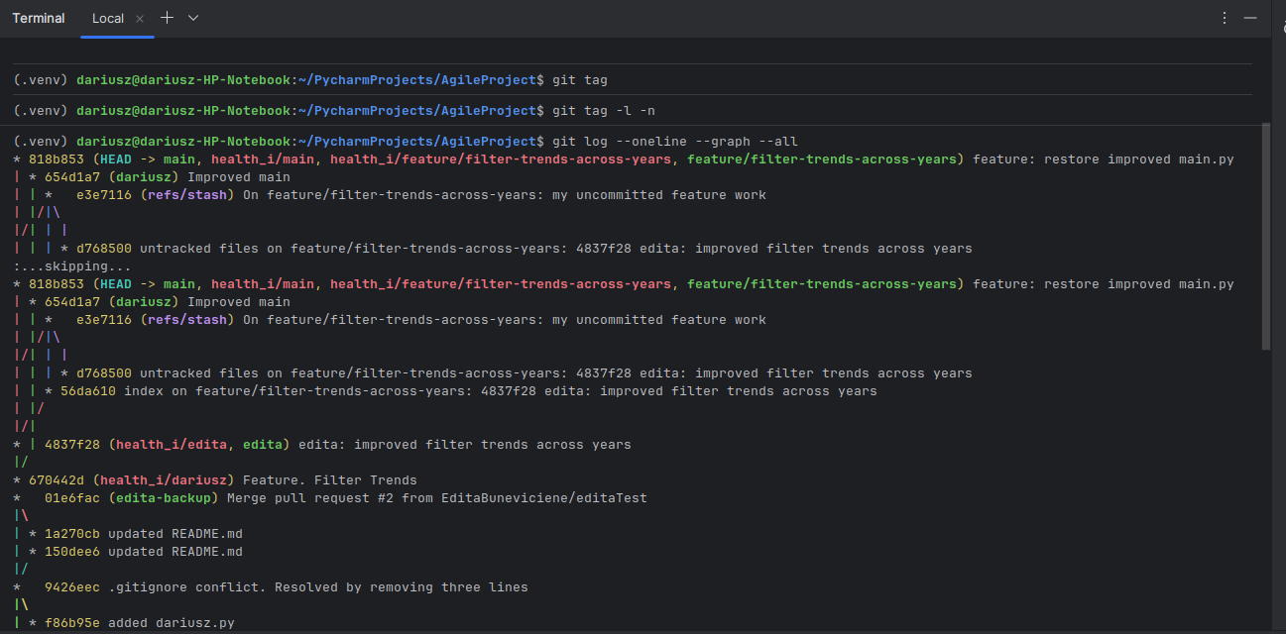Creating tag for Sprint 1

Creating tag for Sprint 2:

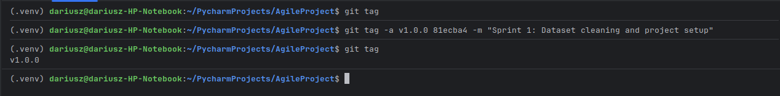

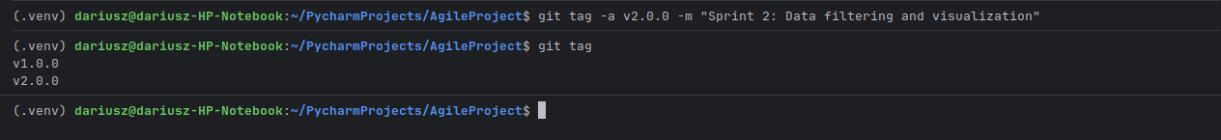

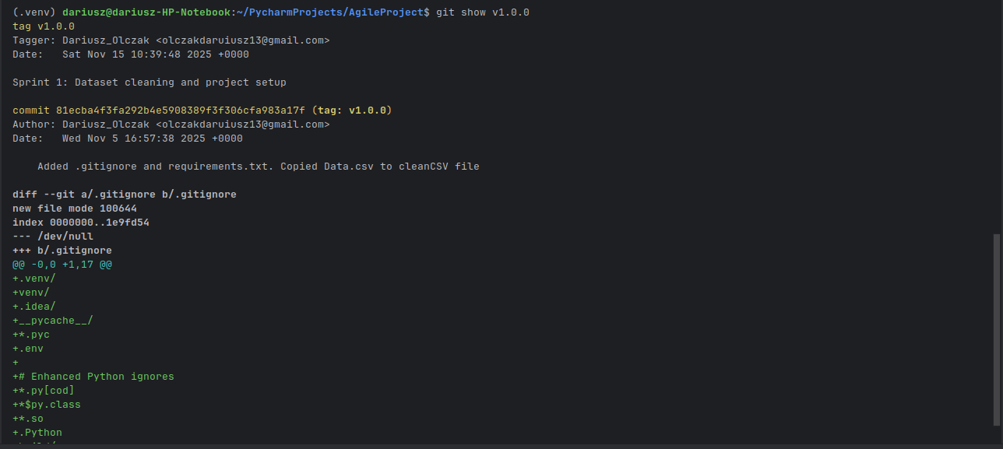Checking content of Tag v1.0.0

Checking for content of Tag v2.0.0

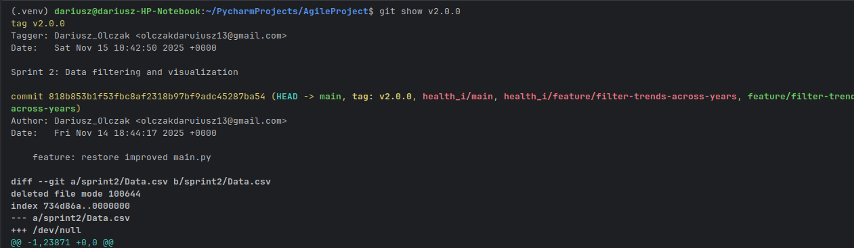

Pushing changes (added Tags) to remote:

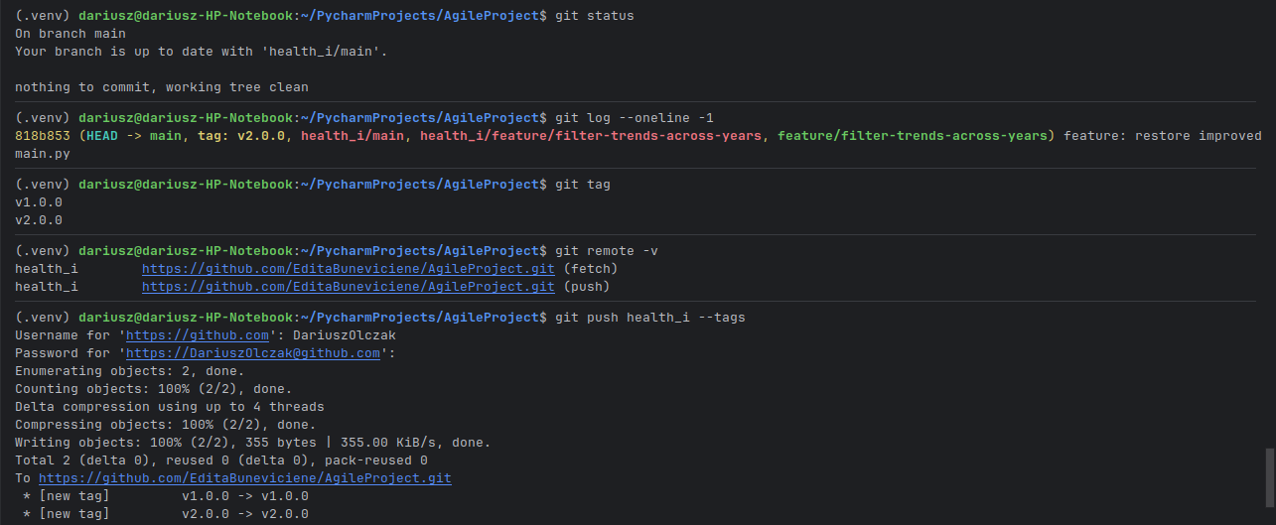

# Sprint review

Sprint 2 daily /weekly scrum meeting

All team members should provide their priorities, progress, and problems each day in this report.

|  |  |
| --- | --- |
| **Team name** | evSD |
| **Direct supervisor** | Srum master Dariusz |
| **Table of contents** | * [\uD83D\uDDD3 Week1 <03/11/2025>](" \l "Sprint2daily/weeklyscrummeeting-Week1<03/11/2025>) * [\uD83D\uDDD3 Week 2 <10/11/2025>](" \l "Sprint2daily/weeklyscrummeeting-Week2<10/11/2025>) * [\uD83D\uDDD3 Wednesday <12/11/25>](" \l "Sprint2daily/weeklyscrummeeting-Wednesday<12/11/25>) |

## IMG_264 Week1 <03/11/2025>

|  |  |  |  |  |
| --- | --- | --- | --- | --- |
|  | **Name** | **Priorities IMG_265** | **Progress IMG_266** | **Problems IMG_267** |
| 1 | [evSD\_Group1](https://evsd1.atlassian.net/people/team/0e2cf7b2-c5c3-4df7-918b-1b9e97b6d486) ([Edita Buneviciene](https://evsd1.atlassian.net/wiki/people/712020:d55b7260-2e5b-49d6-87e6-228b14f15d65?ref=confluence" \t "_blank) [Dariusz Olczak](https://evsd1.atlassian.net/wiki/people/70121:36abc9b4-dd97-4b78-a15c-ba8450bb8d25?ref=confluence" \t "_blank) [Ed Tracey](https://evsd1.atlassian.net/wiki/people/712020:22df8da7-d258-4e96-a565-5d1f5c417764?ref=confluence" \t "_blank) [Patrick Strand](https://evsd1.atlassian.net/wiki/people/712020:06192cf4-96c0-4b29-a4dc-6553536b0765?ref=confluence" \t "_blank)) | Decide what information implement in user stories | Details in user story description |  |
| 2 | [evSD\_Group1](https://evsd1.atlassian.net/people/team/0e2cf7b2-c5c3-4df7-918b-1b9e97b6d486) ([Edita Buneviciene](https://evsd1.atlassian.net/wiki/people/712020:d55b7260-2e5b-49d6-87e6-228b14f15d65?ref=confluence" \t "_blank) [Dariusz Olczak](https://evsd1.atlassian.net/wiki/people/70121:36abc9b4-dd97-4b78-a15c-ba8450bb8d25?ref=confluence" \t "_blank) [Ed Tracey](https://evsd1.atlassian.net/wiki/people/712020:22df8da7-d258-4e96-a565-5d1f5c417764?ref=confluence" \t "_blank) [Patrick Strand](https://evsd1.atlassian.net/wiki/people/712020:06192cf4-96c0-4b29-a4dc-6553536b0765?ref=confluence" \t "_blank)) | Pick a scrum master and PO | Scrum master and PO selected |  |
| 3 | [Ed Tracey](https://evsd1.atlassian.net/wiki/people/712020:22df8da7-d258-4e96-a565-5d1f5c417764?ref=confluence" \t "_blank) [Patrick Strand](https://evsd1.atlassian.net/wiki/people/712020:06192cf4-96c0-4b29-a4dc-6553536b0765?ref=confluence" \t "_blank)) | Research on HTML visualization | Working on it. |  |

## IMG_264 Week 2 <10/11/2025>

|  |  |  |  |  |
| --- | --- | --- | --- | --- |
|  | **Name** | **Priorities IMG_265** | **Progress IMG_266** | **Problems IMG_267** |
| 1 | [Dariusz Olczak](https://evsd1.atlassian.net/wiki/people/70121:36abc9b4-dd97-4b78-a15c-ba8450bb8d25?ref=confluence" \t "_blank) | * Connect Jira and git. * Connect with Patrick to work on displaying data. * Create short report on tasks. |  |  |
| 2 | [Ed Tracey](https://evsd1.atlassian.net/wiki/people/712020:22df8da7-d258-4e96-a565-5d1f5c417764?ref=confluence" \t "_blank) | * Git report and checklist. * Sprint2 user stories, subtasks acceptance criteria. * Create short report on tasks. * Update meeting minutes. |  |  |
| 3 | [Patrick Strand](https://evsd1.atlassian.net/wiki/people/712020:06192cf4-96c0-4b29-a4dc-6553536b0765?ref=confluence" \t "_blank) | * Update sprint user stories and subtasks. * Setup git on local machine and clone repo. * Create short report on tasks. |  |  |
| 4 | [Edita Buneviciene](https://evsd1.atlassian.net/wiki/people/712020:d55b7260-2e5b-49d6-87e6-228b14f15d65?ref=confluence" \t "_blank) | * Write the script for a subtask. * Create short report on tasks. | Write main.py to display graphs/charts |  |

## IMG_264 Wednesday <12/11/25>

|  |  |  |  |  |
| --- | --- | --- | --- | --- |
|  | **Name** | **Priorities IMG_265** | **Progress IMG_266** | **Problems IMG_267** |
| 1 | [evSD\_Group1](https://evsd1.atlassian.net/people/team/0e2cf7b2-c5c3-4df7-918b-1b9e97b6d486) ([Edita Buneviciene](https://evsd1.atlassian.net/wiki/people/712020:d55b7260-2e5b-49d6-87e6-228b14f15d65?ref=confluence" \t "_blank) [Dariusz Olczak](https://evsd1.atlassian.net/wiki/people/70121:36abc9b4-dd97-4b78-a15c-ba8450bb8d25?ref=confluence" \t "_blank) [Ed Tracey](https://evsd1.atlassian.net/wiki/people/712020:22df8da7-d258-4e96-a565-5d1f5c417764?ref=confluence" \t "_blank) [Patrick Strand](https://evsd1.atlassian.net/wiki/people/712020:06192cf4-96c0-4b29-a4dc-6553536b0765?ref=confluence" \t "_blank)) | * take screenshot continuously of work * Add more details user stories and subtask descriptions |  |  |

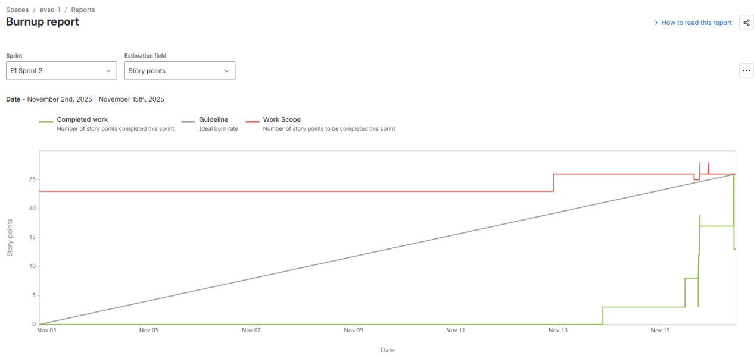

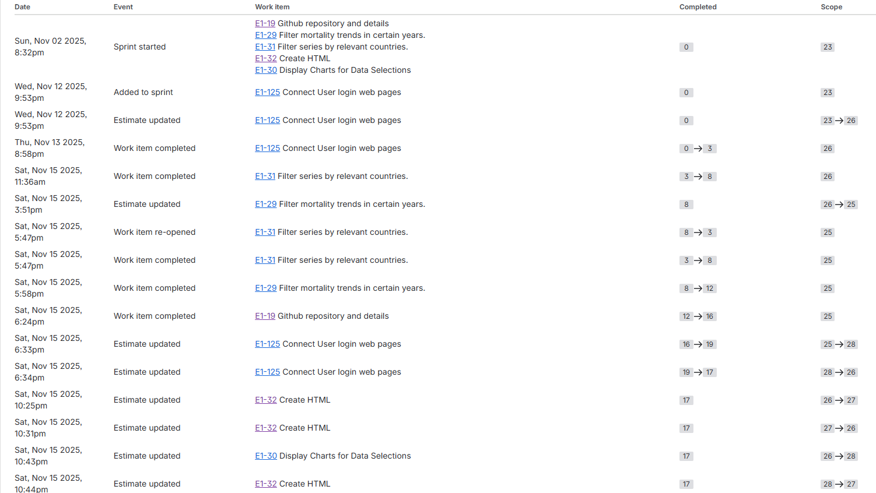

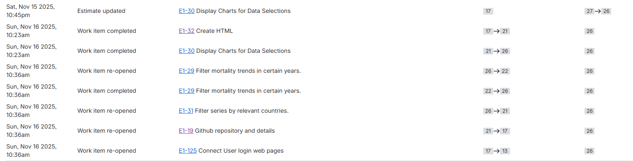

Sprint 2 Burndown chart

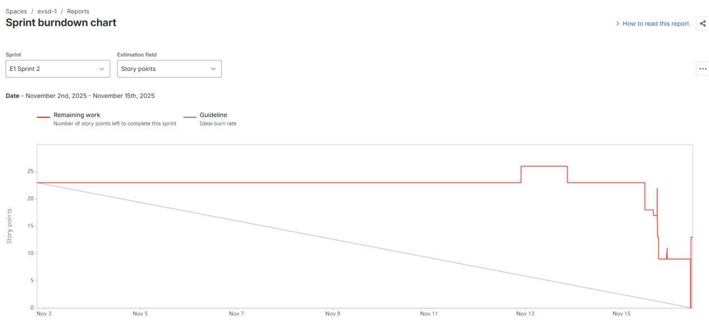

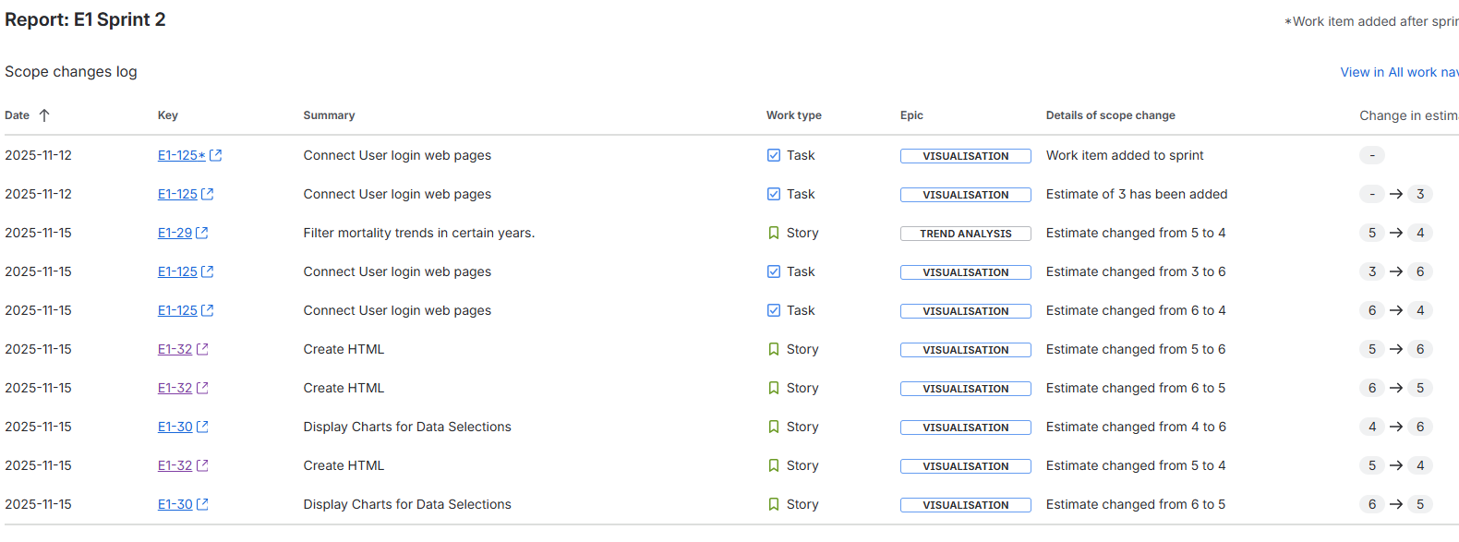

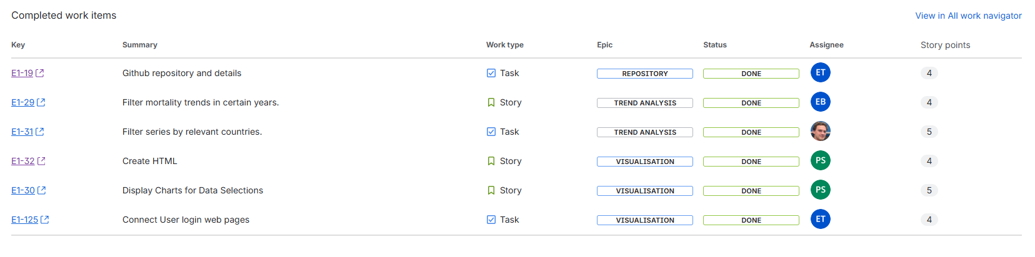

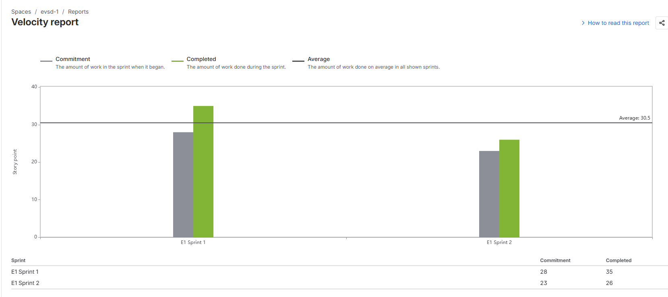

# evsd-1 (E1) - E1 Sprint 2

# ****Sprint Summary****

**Sprint Dates:** 02 Nov 2025 to 15 Nov 2025

This sprint focuses on the following goals.

* Finish the web login interface and test it’s functionality.
* Document the git workflow and record any additions to the repository with screenshots and descriptions.
* Ensure the data set is clean and accessible via the home page.
* Create the home page interface to visualize selections of the data set on a graph.

# ****Sprint Detail****

## Completed

|  |  |  |  |  |  |
| --- | --- | --- | --- | --- | --- |
| **Key** | **Summary** | **Story Points** | **Planned** | **Comment** | **Feedback** |
| [E1-29](http://evsd1.atlassian.net/browse/E1-29) | Filter mortality trends in certain years. | 4 | YES |  |  |
| [E1-19](http://evsd1.atlassian.net/browse/E1-19) | Github repository and details | 4 | YES |  |  |
| [E1-32](http://evsd1.atlassian.net/browse/E1-32) | Create HTML | 4 | YES |  |  |
| [E1-30](http://evsd1.atlassian.net/browse/E1-30) | Display Charts for Data Selections | 5 | YES |  |  |
| [E1-31](http://evsd1.atlassian.net/browse/E1-31) | Filter series by relevant countries. | 5 | YES |  |  |
| [E1-125](http://evsd1.atlassian.net/browse/E1-125) | Connect User login web pages | 4 | NO |  |  |

## In progress

No issues in progress

## Not started

No issues started

## Added

|  |  |  |  |  |  |
| --- | --- | --- | --- | --- | --- |
| **Key** | **Summary** | **Story Points** | **Planned** | **Comment** | **Feedback** |
| [E1-125](http://evsd1.atlassian.net/browse/E1-125) | Connect User login web pages | 4 | NO |  |  |

## Removed

No issues removed

# ****Impediments & Risks****

Impediments

|  |  |  |  |
| --- | --- | --- | --- |
| **Title / Description** | **Impact** | **Status** | **Action taken** |
| The final home page is still in development and the data set needs more processing. | Small | Resolved | A temporary home page was created to allow column selection from a dummy data set for displaying a graph. |
| Training for git commands and deciding on a compatible git workflow. | Small | Resolved | A document outlining the procedure for branch, committing, pull requests, etc., was created so the team could familiarize itself with procedure. |
| Data visualization development needed to be prioritized to meet the sprint due date. | Medium | Resolved | Members of the development Team, (Patrick & Dariusz), paired together to complete the task. |

Risks

|  |  |  |  |
| --- | --- | --- | --- |
| **Title / Description** | **Impact** | **Likelihood** | **Action taken** |
| Towards the end of the Sprint there was a risk of not meeting the due date due to the number of tasks in the sprint. | Medium |  | Each task was revisited and any details that were unclear were updated. A number of tasks were then able to be removed due to overlapping work or repeated tasks. This reduced the overall workload and focused the work more clearly on the objectives of the sprint. |
| Risk of incomplete tasks becoming blockers for other tasks. | Medium |  | The frequency of planning meetings and short communication calls between the development team members was increased to ensure that the team was always aware of the status and progress of related tasks in the Sprint. |

Reflect on past work and identify opportunities for improvement by following the instructions for the [Retrospective Play](https://www.atlassian.com/team-playbook/plays/retrospective).

## IMG_256 Overview

|  |  |
| --- | --- |
| **Date** | 10 Nov 2025 |
| **Team** | evsd-1 |
| **Participants** | Edita Buneviciene, Dariusz Olczak, Patrick Strand, Edward Tracey |

## IMG_257 Retrospective

|  |  |  |
| --- | --- | --- |
| **IMG_258 Start doing** | **IMG_259 Stop doing** | **IMG_260 Keep doing** |
| Document each task with a basic cheat sheet. | Ensure any tasks that may overlap do not end up as duplicate tasks. | Updating the subtasks and DoD details. |
| Ensure a clear definition of the acceptance criteria has been outlined before a task has started. | Don't let tasks sit for long periods without updating. | Keep updating the backlog to reflect the changes in priority and eliminate any redundant tasks. |
| Meeting topics should be limited to 10 minutes. If longer is needed then a separate meeting involving the relevant developers should be scheduled. | Unless a task is blocked, complete existing tasks in the sprint before starting a new one, especially when it comes close to the end of a sprint. | Revisiting the story point descriptions and done definitions to help focus the objectives. |
| For complex tasks the work should be paired between developers to ensure the knowledge is spread and help the task complete faster. | Creating test branches on the remote repo can make the tree look confusing and hard to follow. Any test branches should be local and all merges back into main should be done via pull requests/reviews. | Keep the collaboration and communication regular. |
| Update dates for task completion once the task has started to help view the project progress. | A definitive and understandable path for the project should be outlined as early as possible. (Module description) | Periodic meetings and discussions on the relevant tasks. |

## IMG_261 Action items

* Create a checklist for description, dod, subtasks with details, story point values, that should be completed before the task is added to the sprint.
* To keep the git tree looking tidy, ensure all merges into main are done via a pull request and update the git readme details if anything is unclear.
* Ensure meeting topics don’t run overtime by setting 10 mins max per topic.
* Document all tasks with a quick cheat sheet with info on the task and screenshots/diagrams to help ensure the final report can be assembled quicker.

# ****Other updates****

# ****What’s next****

* Sprint 3

# Sprint 2 retrospective

Reflect on past work and identify opportunities for improvement by following the instructions for the [Retrospective Play](https://www.atlassian.com/team-playbook/plays/retrospective).

## IMG_256 Overview

|  |  |
| --- | --- |
| **Date** | 10 Nov 2025 |
| **Team** | evsd-1 |
| **Participants** | Edita Buneviciene, Dariusz Olczak, Patrick Strand, Edward Tracey |

## IMG_257 Retrospective

|  |  |  |
| --- | --- | --- |
| **IMG_258 Start doing** | **IMG_259 Stop doing** | **IMG_260 Keep doing** |
| Document each task with a basic cheat sheet. | Ensure any tasks that may overlap do not end up as duplicate tasks. | Updating the subtasks and DoD details. |
| Ensure a clear definition of the acceptance criteria has been outlined before a task has started. | Don't let tasks sit for long periods without updating. | Keep updating the backlog to reflect the changes in priority and eliminate any redundant tasks. |
| Meeting topics should be limited to 10 minutes. If longer is needed then a separate meeting involving the relevant developers should be scheduled. | Unless a task is blocked, complete existing tasks in the sprint before starting a new one, especially when it comes close to the end of a sprint. | Revisiting the story point descriptions and done definitions to help focus the objectives. |
| For complex tasks the work should be paired between developers to ensure the knowledge is spread and help the task complete faster. | Creating test branches on the remote repo can make the tree look confusing and hard to follow. Any test branches should be local and all merges back into main should be done via pull requests/reviews. | Keep the collaboration and communication regular. |
| Update dates for task completion once the task has started to help view the project progress. | A definitive and understandable path for the project should be outlined as early as possible. (Module description) | Periodic meetings and discussions on the relevant tasks. |

**Pro tip:** You can also run a retro on a Confluence whiteboard by typing /retro

## IMG_261 Action items

* Create a checklist for description, DoD, subtasks with details, story point values, that should be completed before the task is added to the sprint.
* To keep the git tree looking tidy, ensure all merges into main are done via a pull request and update the git read.me details if anything is unclear.
* Ensure meeting topics don’t run overtime by setting 10 mins max per topic.
* Document all tasks with a quick cheat sheet with info on the task and screenshots/diagrams to help ensure the final report can be assembled quicker.